**________________________________________________________________________**

**Group 1**

**________________________________________________________________________**

**Atila Genc | Mitesh Sharma | Natasha Indi**

________________________________________________________________________

**Project Requirement:**

Option 1:

* Upload a small demo app / code to **git** shared across the team
* Use tools learnt in class to push the code to release (**jenkins**, **maven)**

Option 2:

* Upload a small demo app to one of the **git** account
* Use the other team member’s environment to simulate **testing**, **integration** and **deployment**

________________________________________________________________________

**Project Plan:**

We chose option ( 2 ) for our project.

In this project we created a DevOps environment where:

* Developers can work in parallel
* Each contribution which is added to version control triggers continuous integration job in jenkins where code is build and tests are run
* Successful CI triggers a new release to be created, through jenkins job
* Successful release triggers new deployment

We used the following DevOps tools:

* Java
* Git
* Github (for online source code repository)
* Maven
* Jenkins
* Docker

We integrated these tools so as that a new code will automatically be built, checked whether it conforms to specifications (through continuous integration), a new release version generated with new code and and new release will be redeployed (continuous deployment).

**Project Implementation**

Below are steps taken to implement project with screen shots

**Steps:**

Setup Tools:

1. Install java (screenshots from assignment)

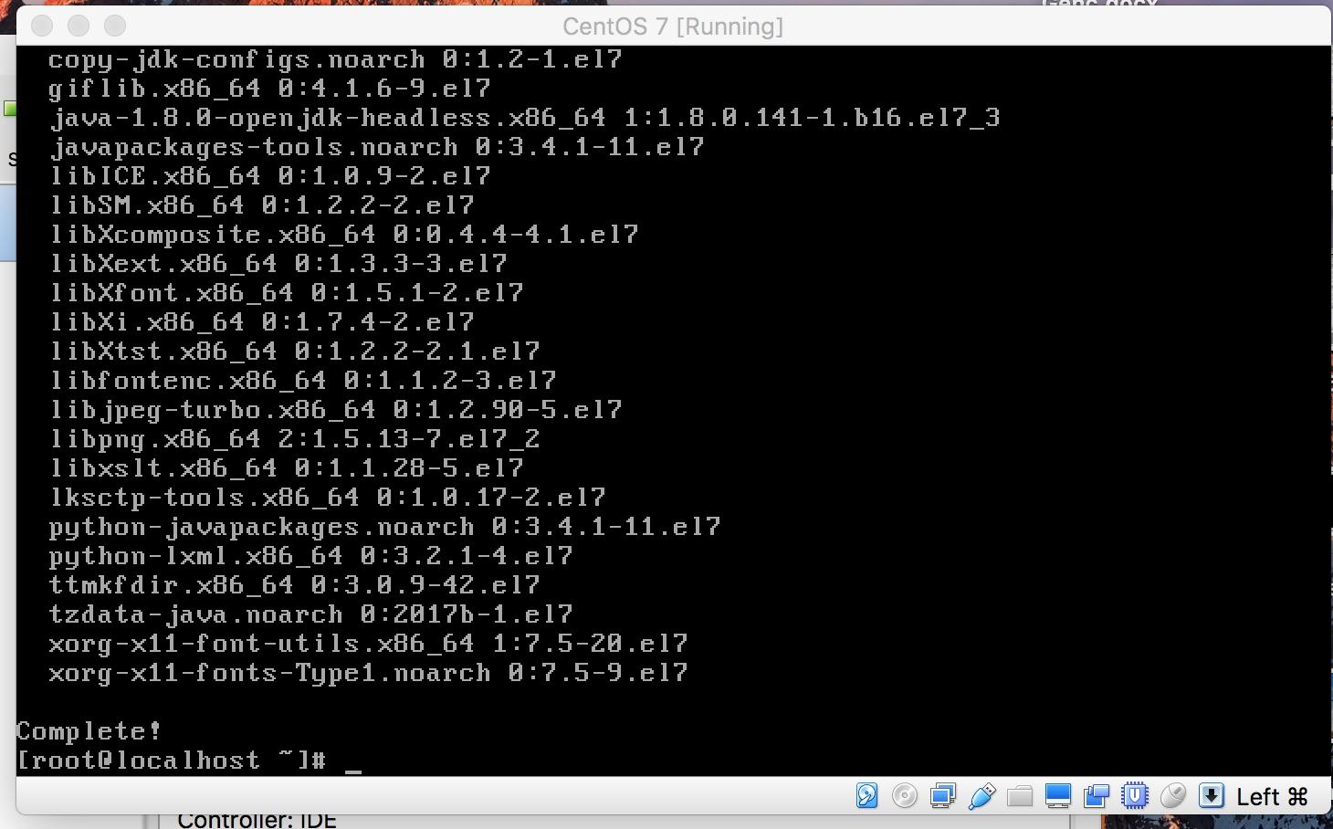

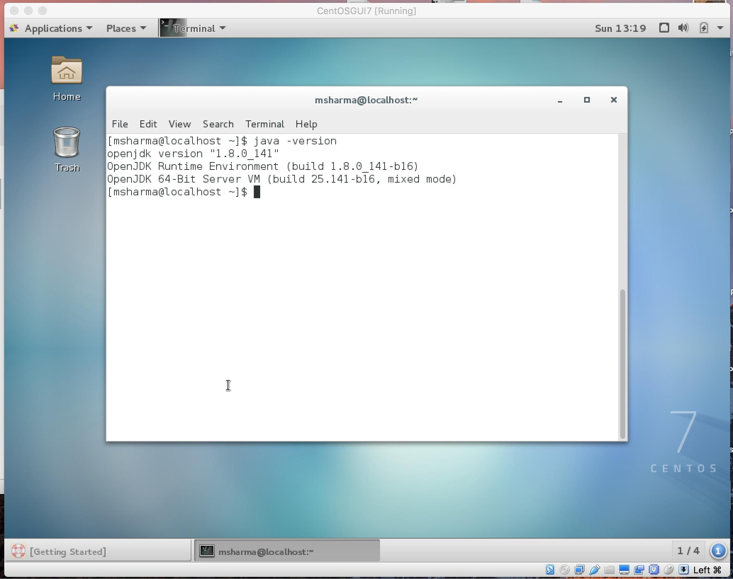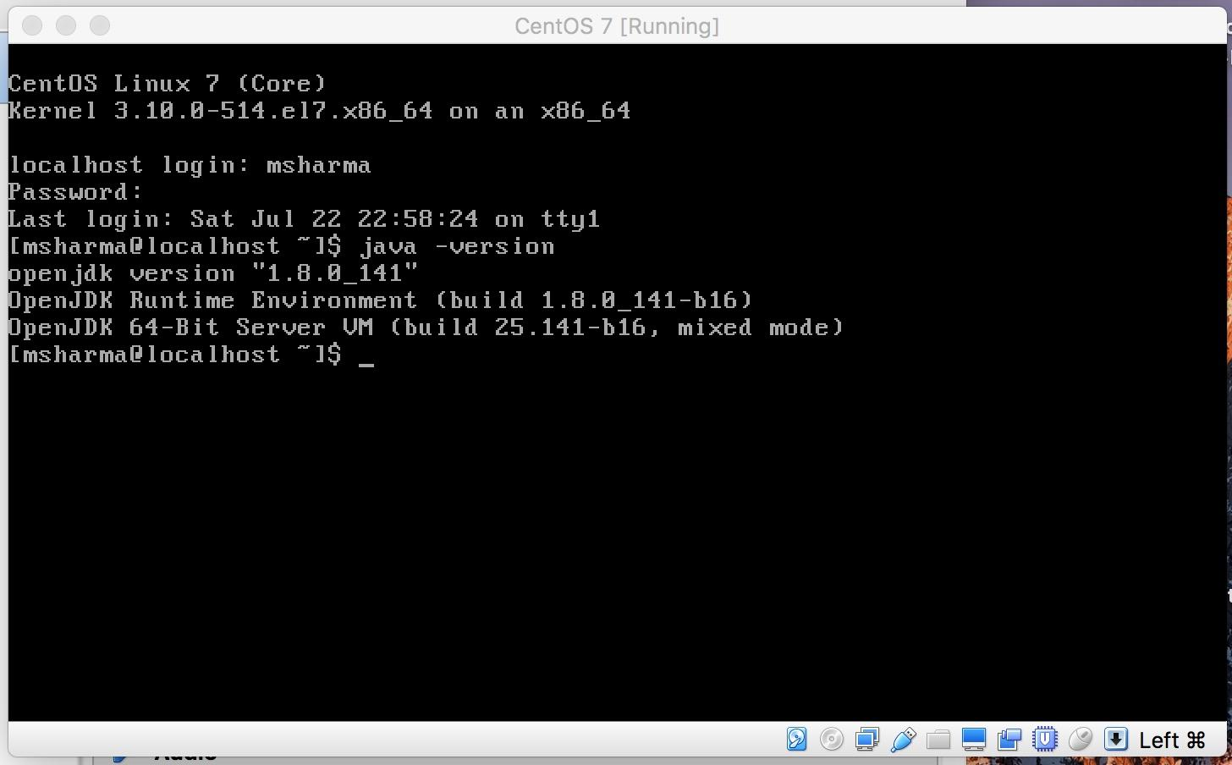

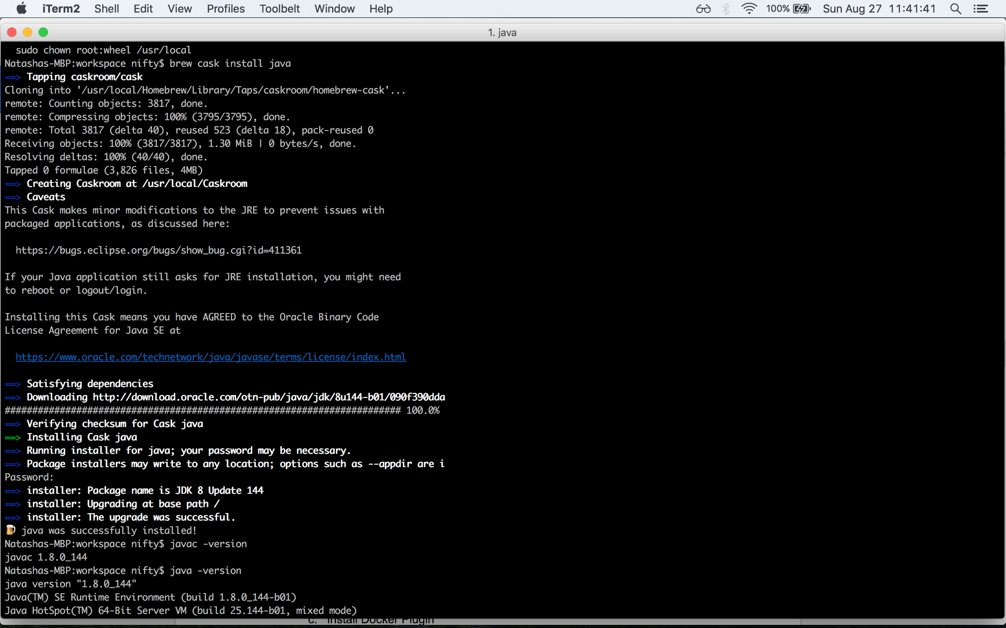

1. Install maven (screenshots from assignment)

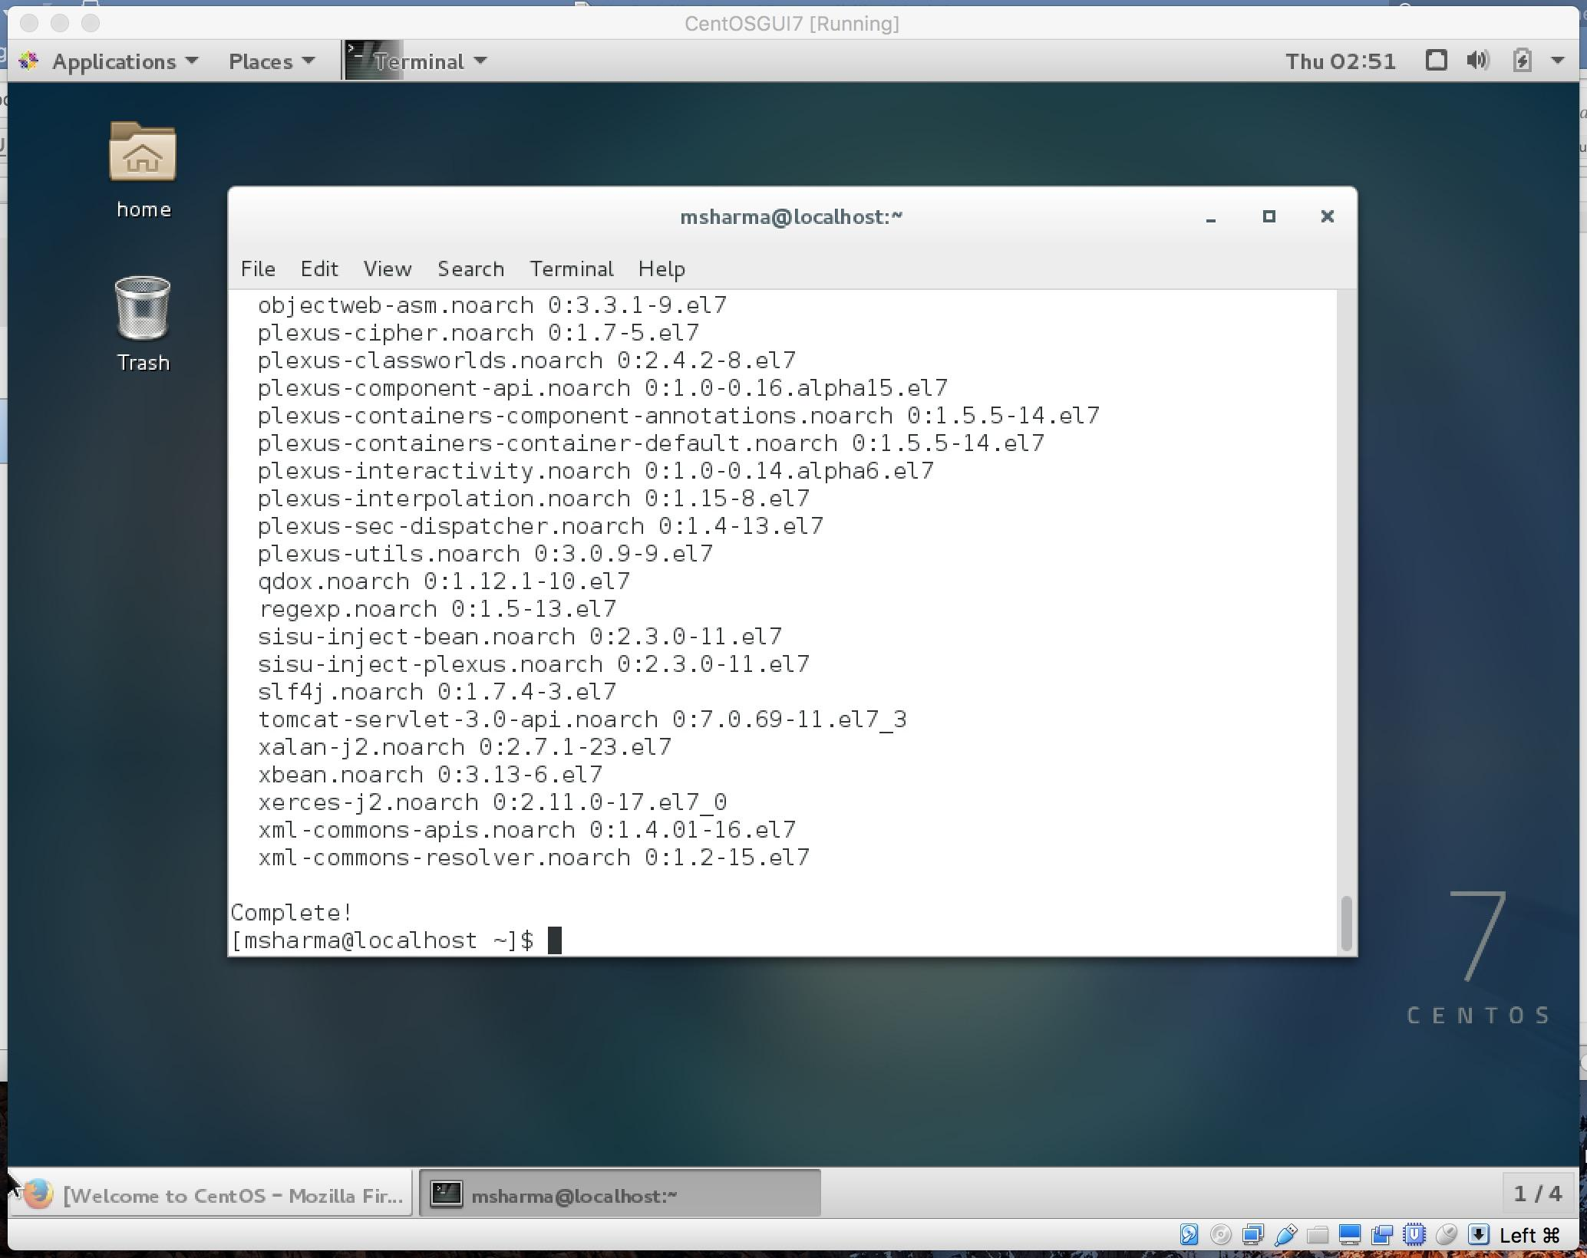

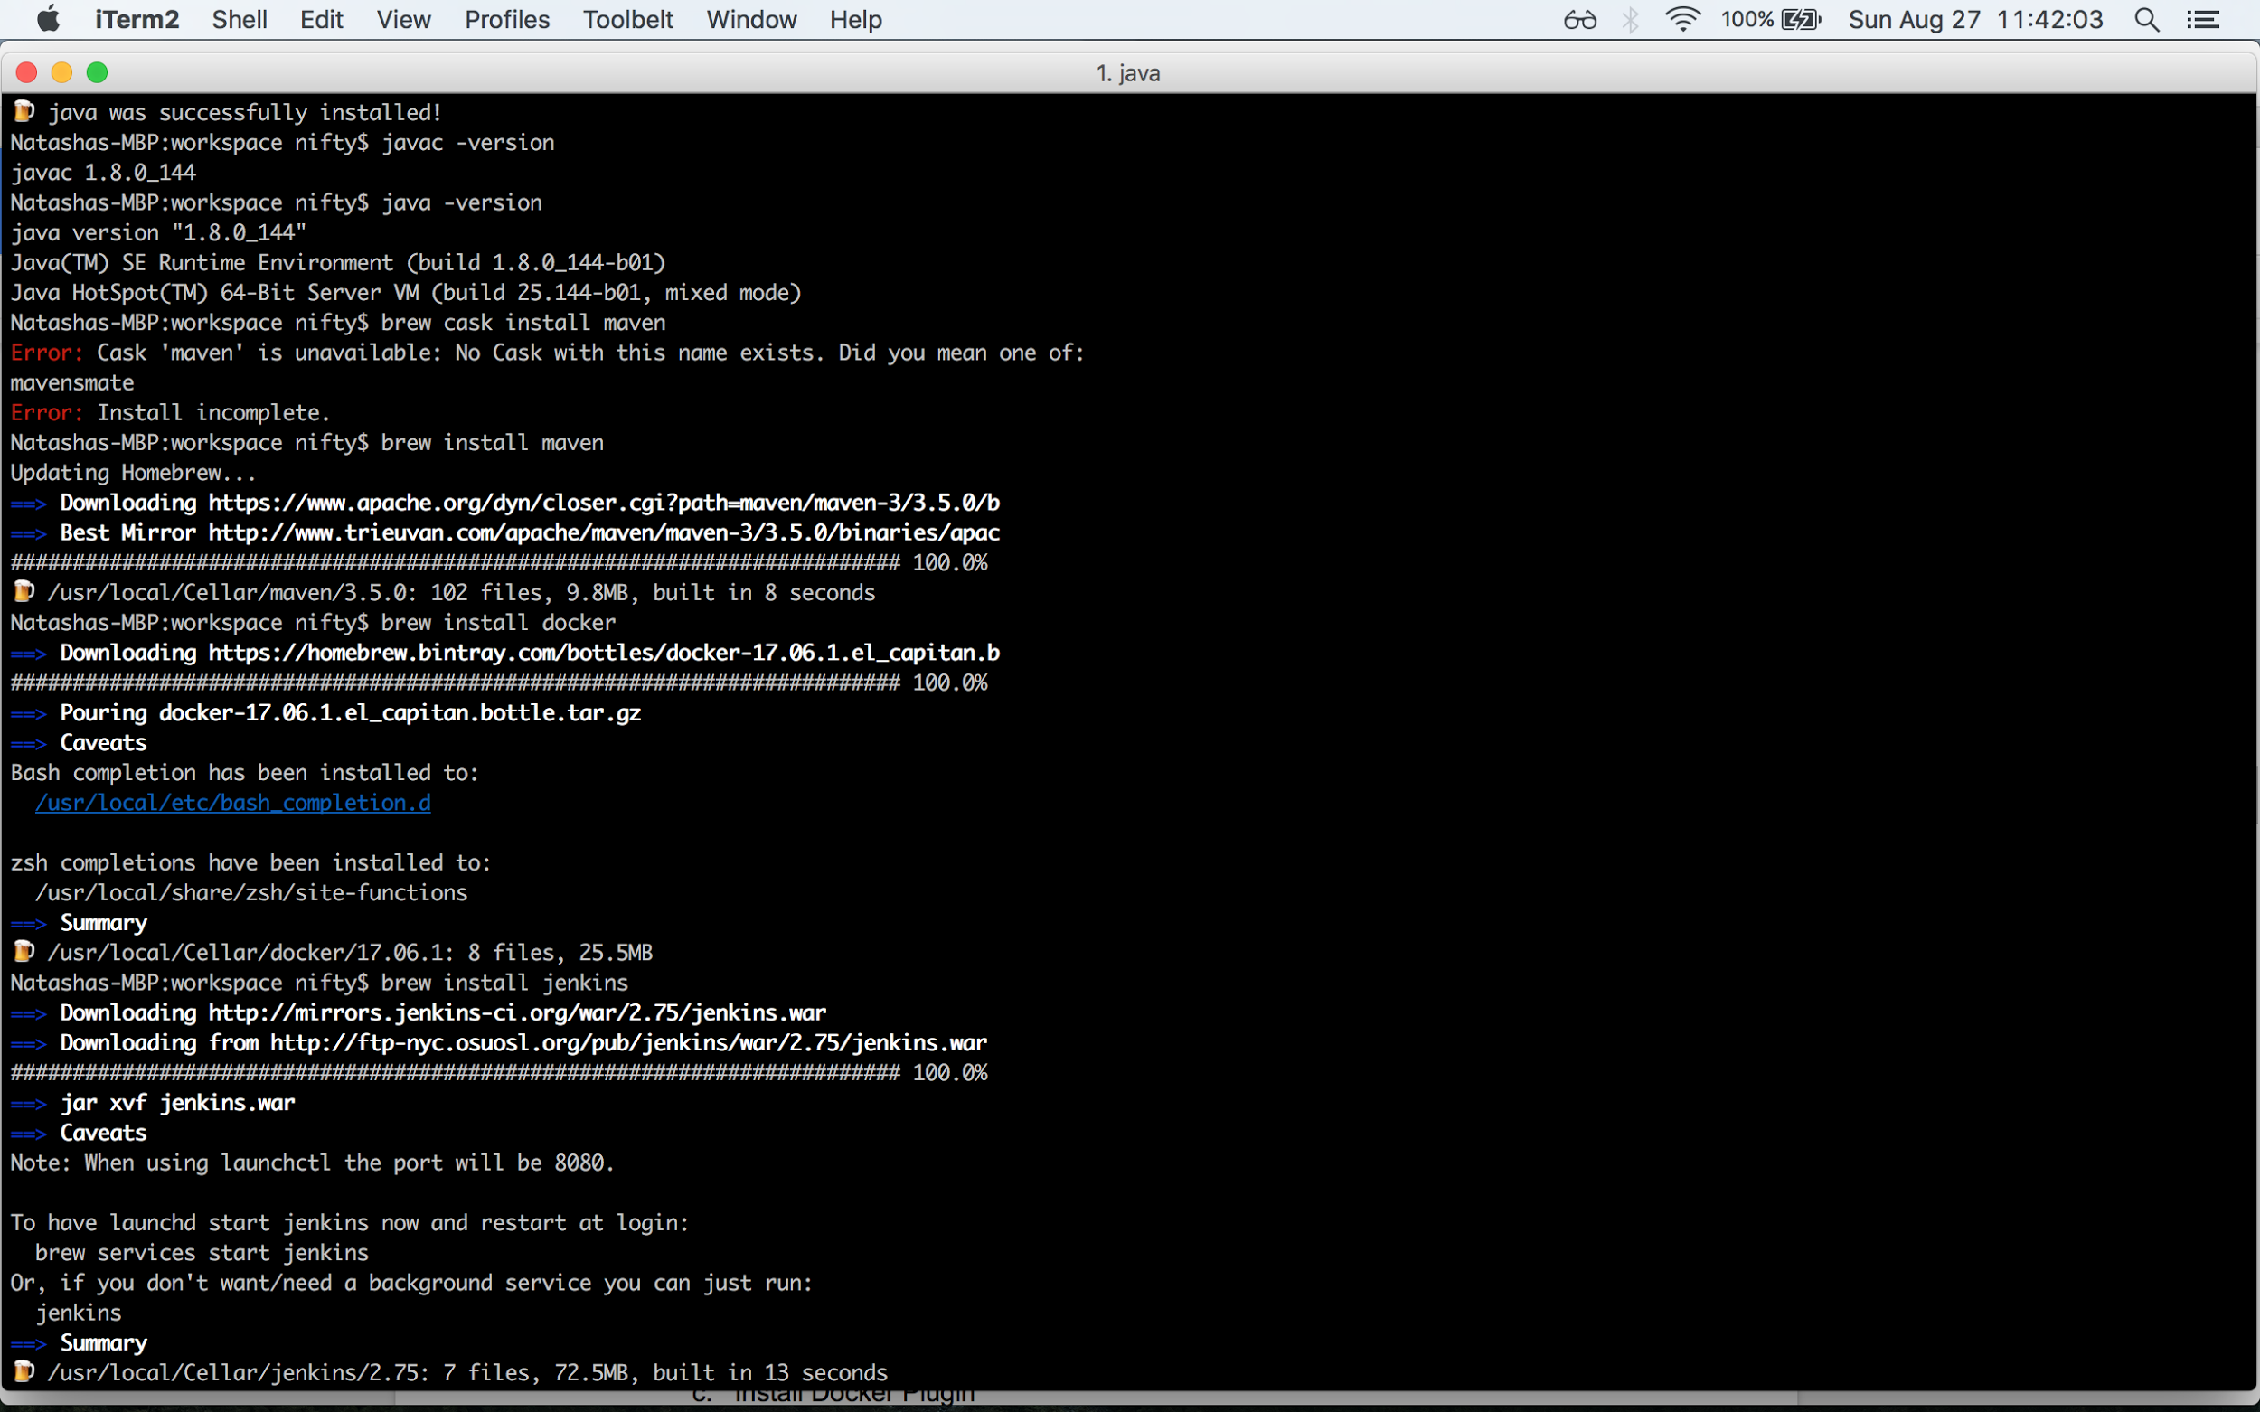

1. Install Docker (screenshots from assignments)

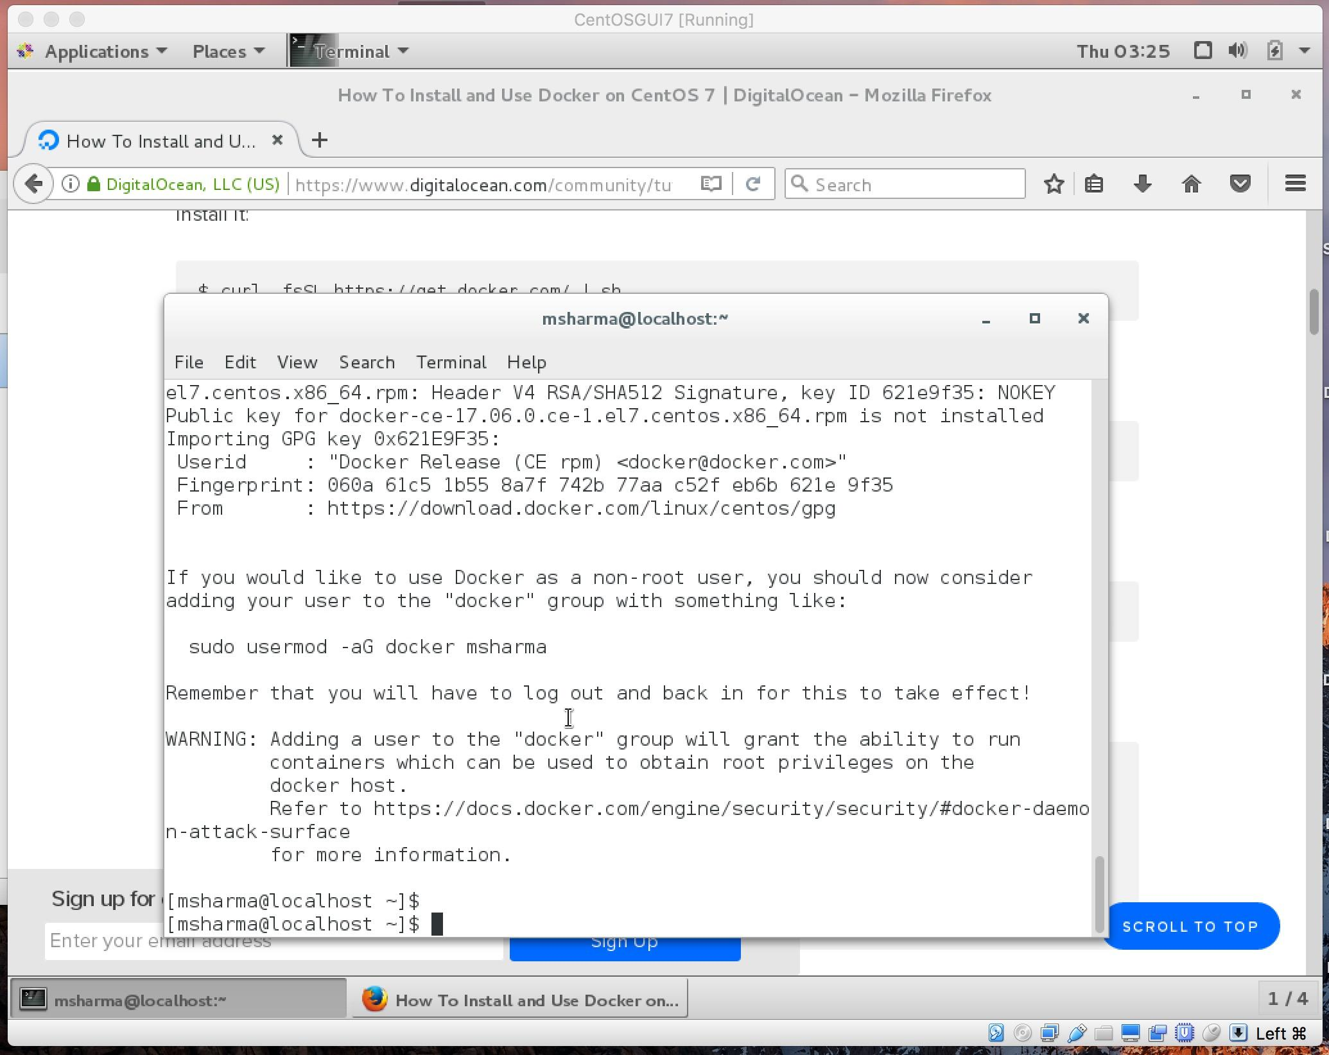

1. Install jenkins (screenshots from assignments)
   1. Install Jenkins

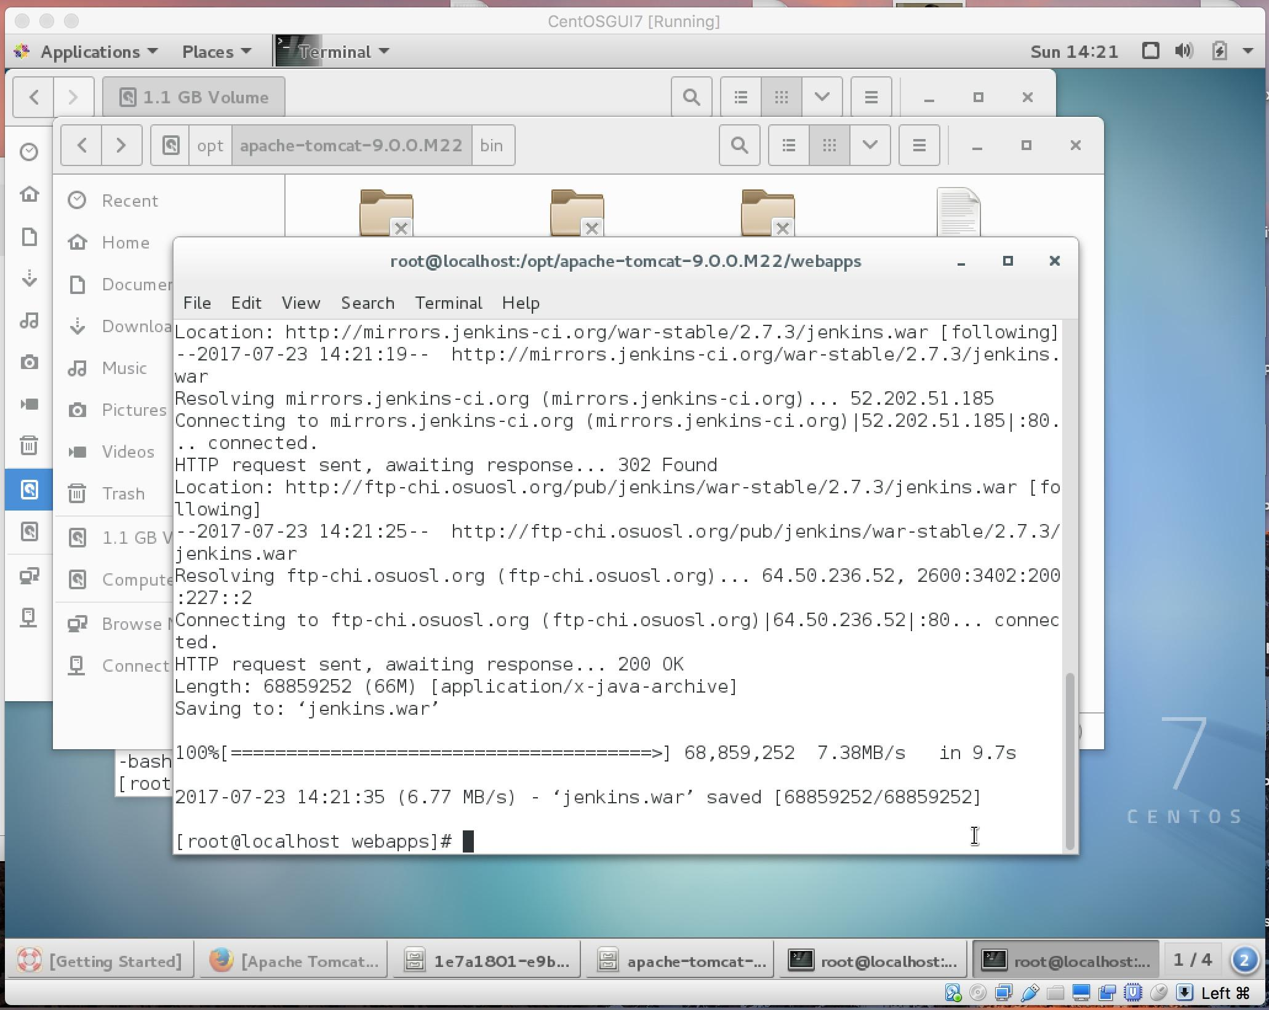

* 1. Install Maven Plugin

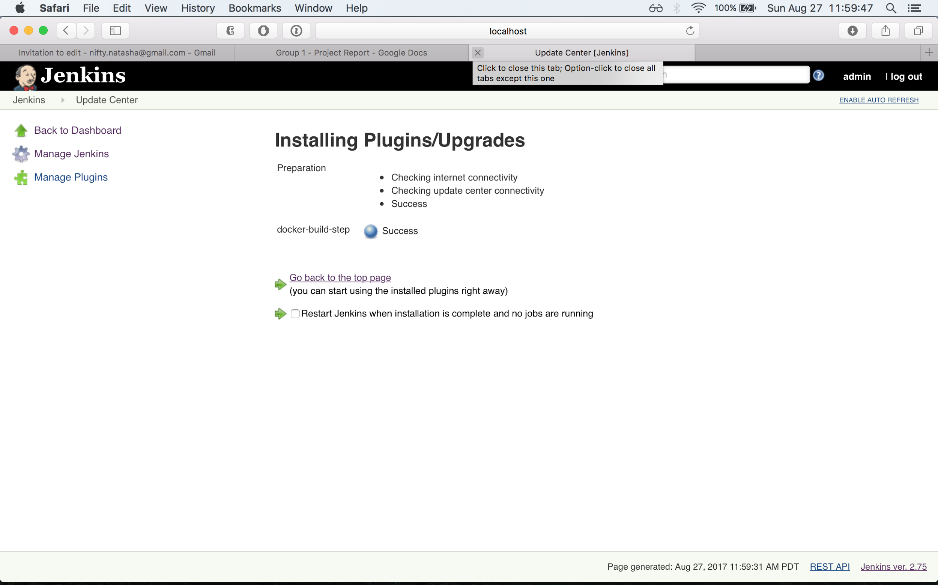

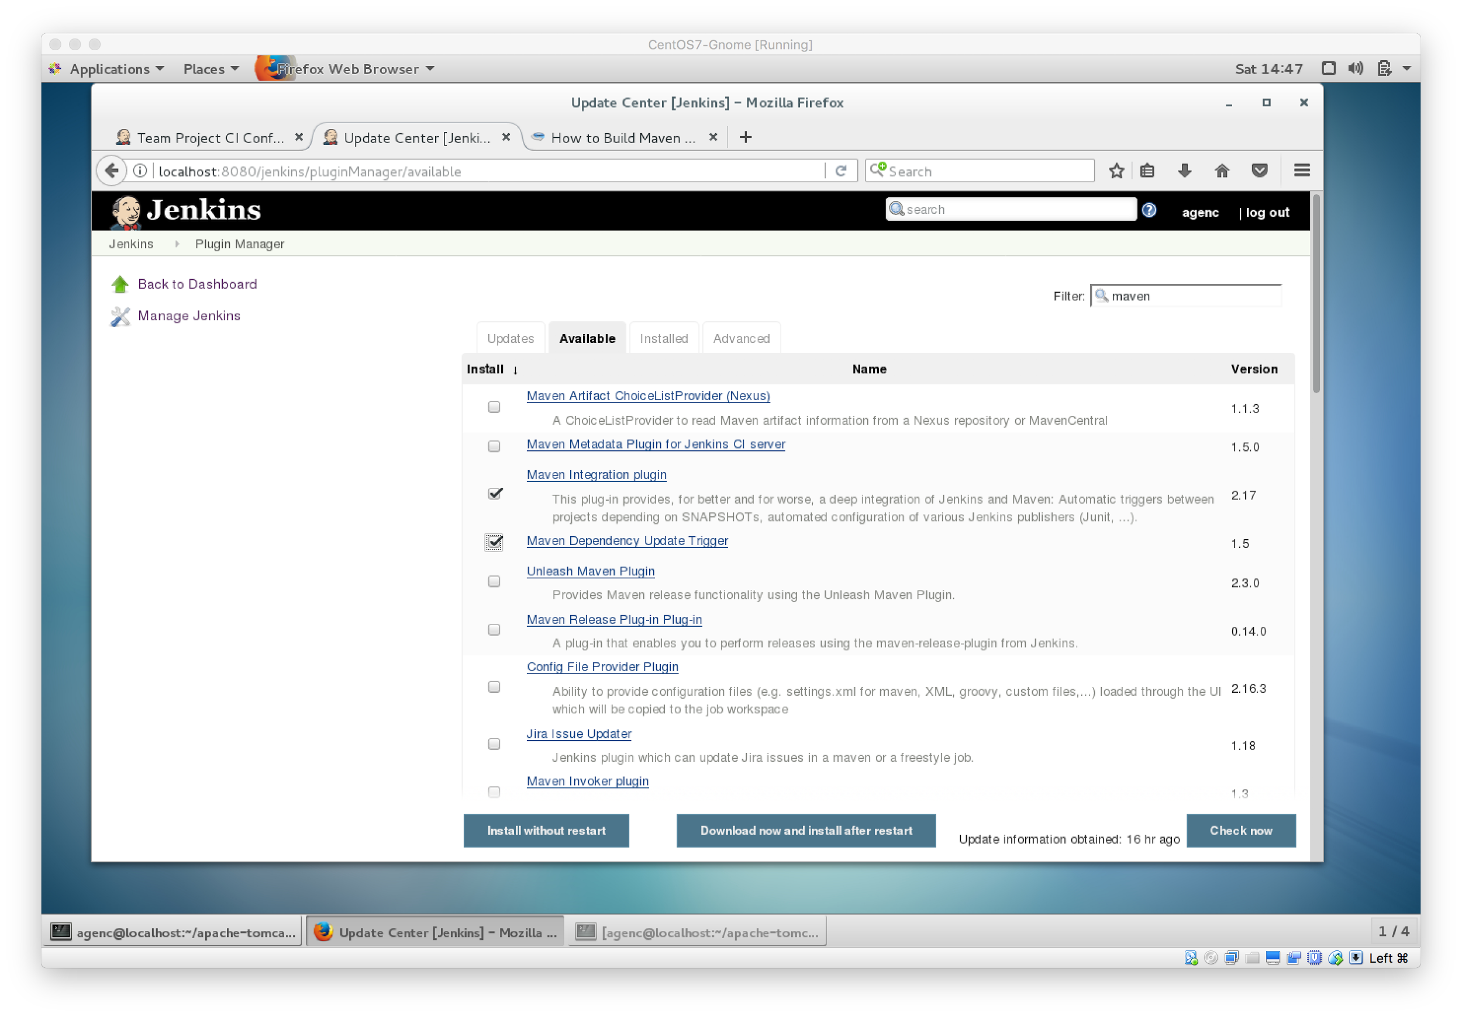

* 1. Install Docker Plugin

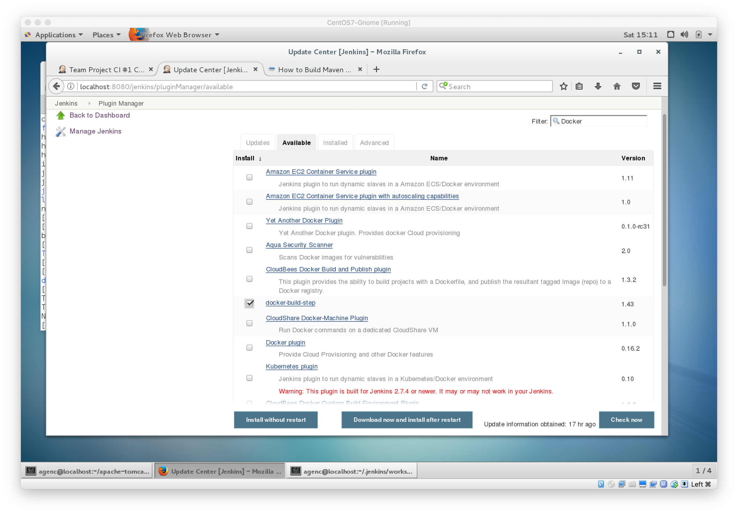

**Setup Project**

1. Created a github account
2. Create and upload ssh keys for passwordless login

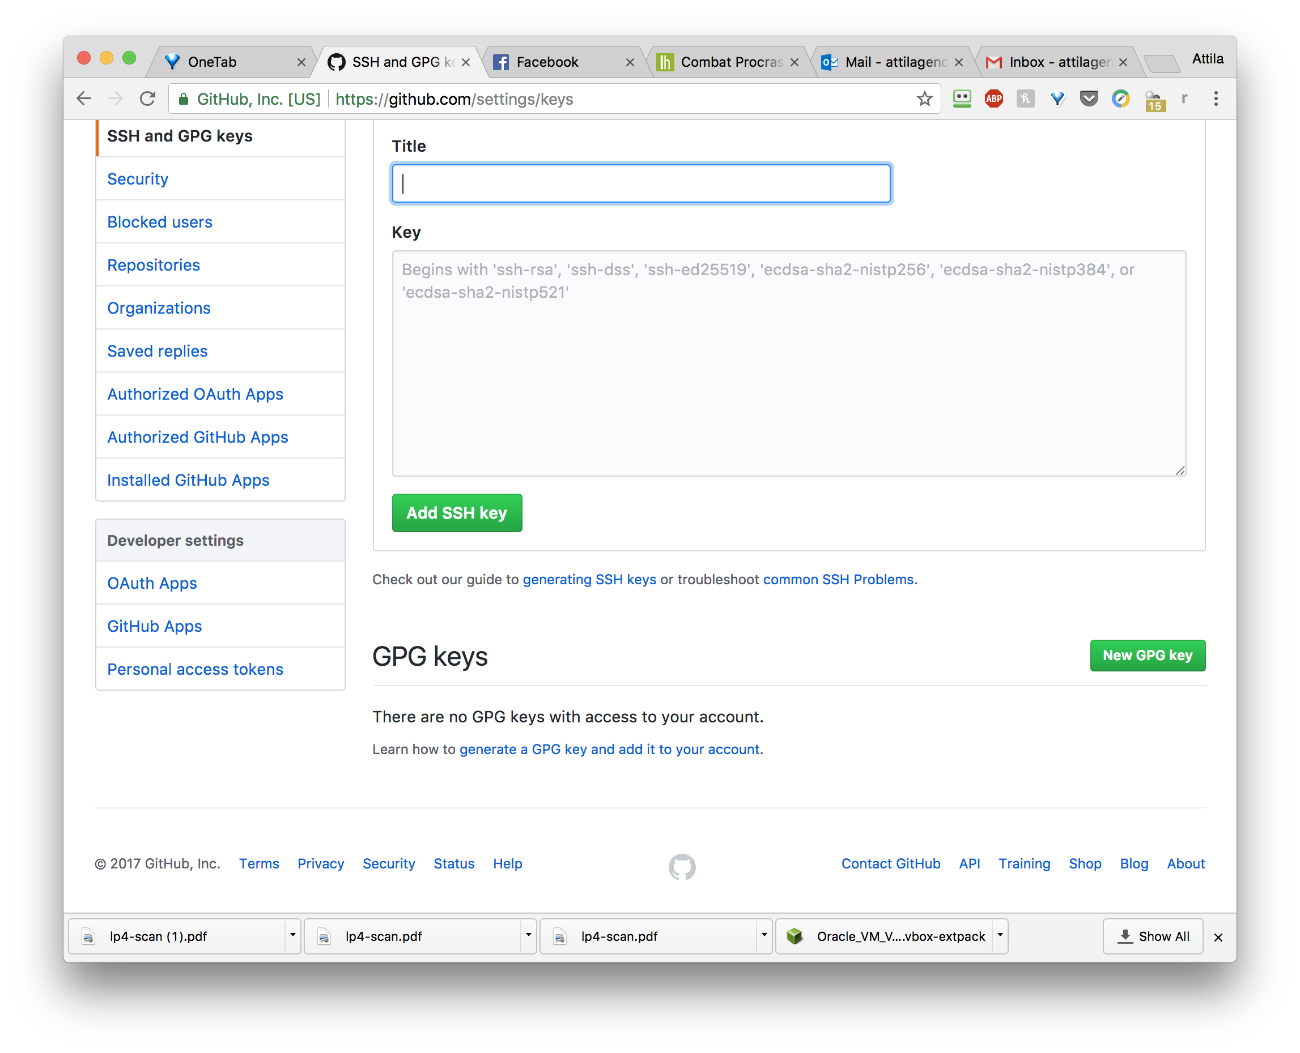

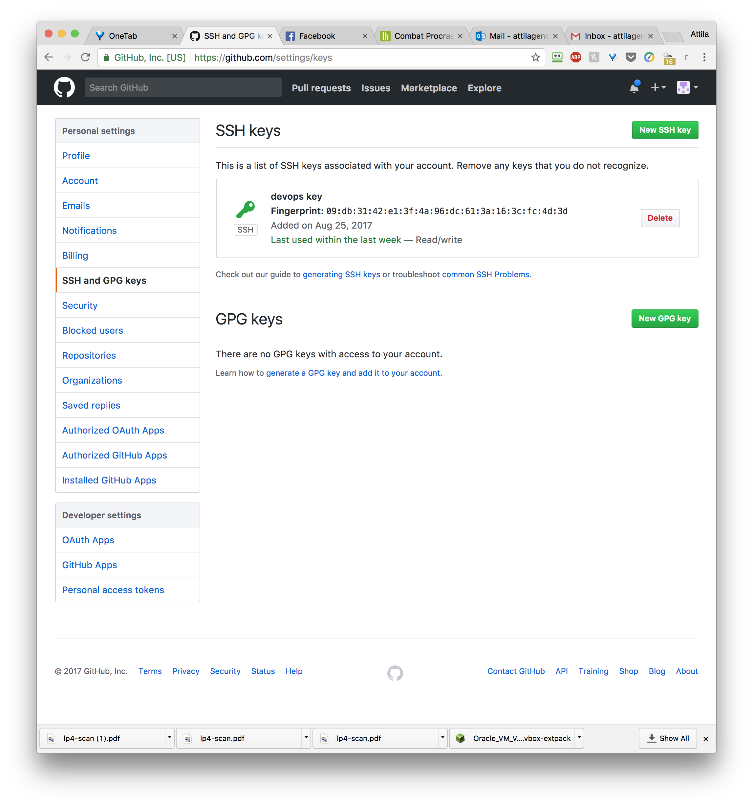

1. Create/Find a Maven project. A sample project was found (<https://github.com/efsavage/hello-world-war>) and was forked 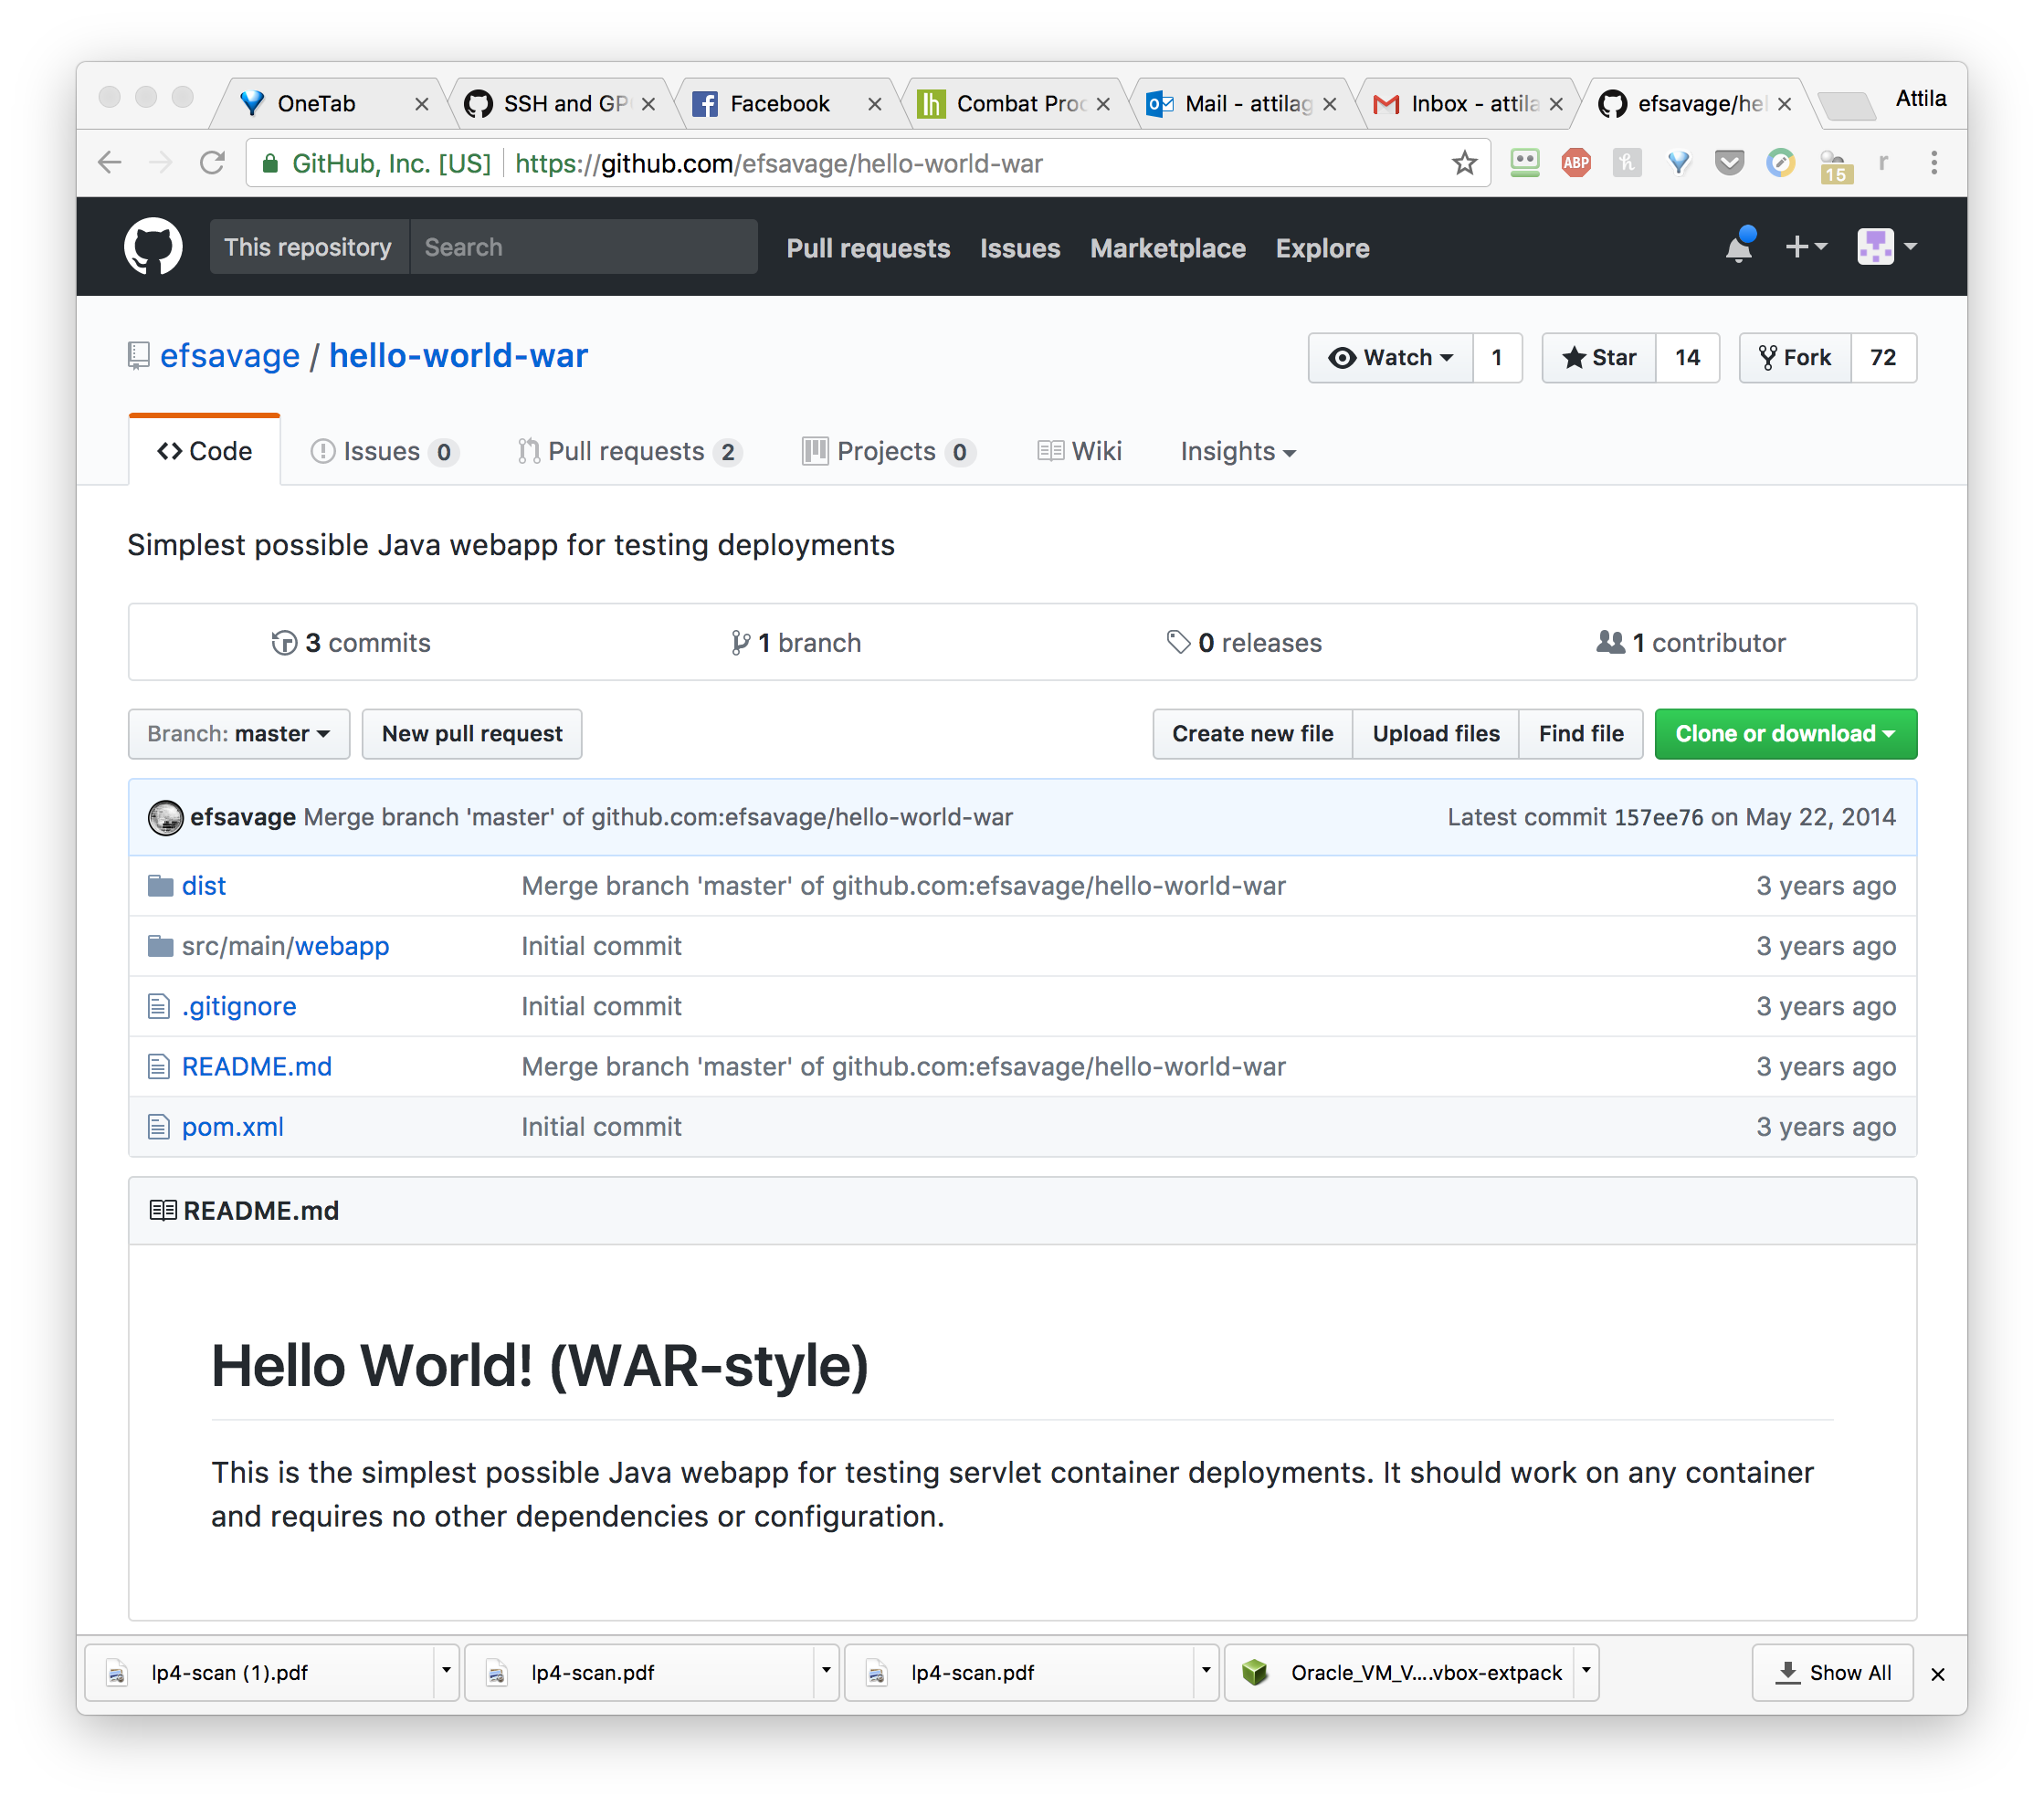

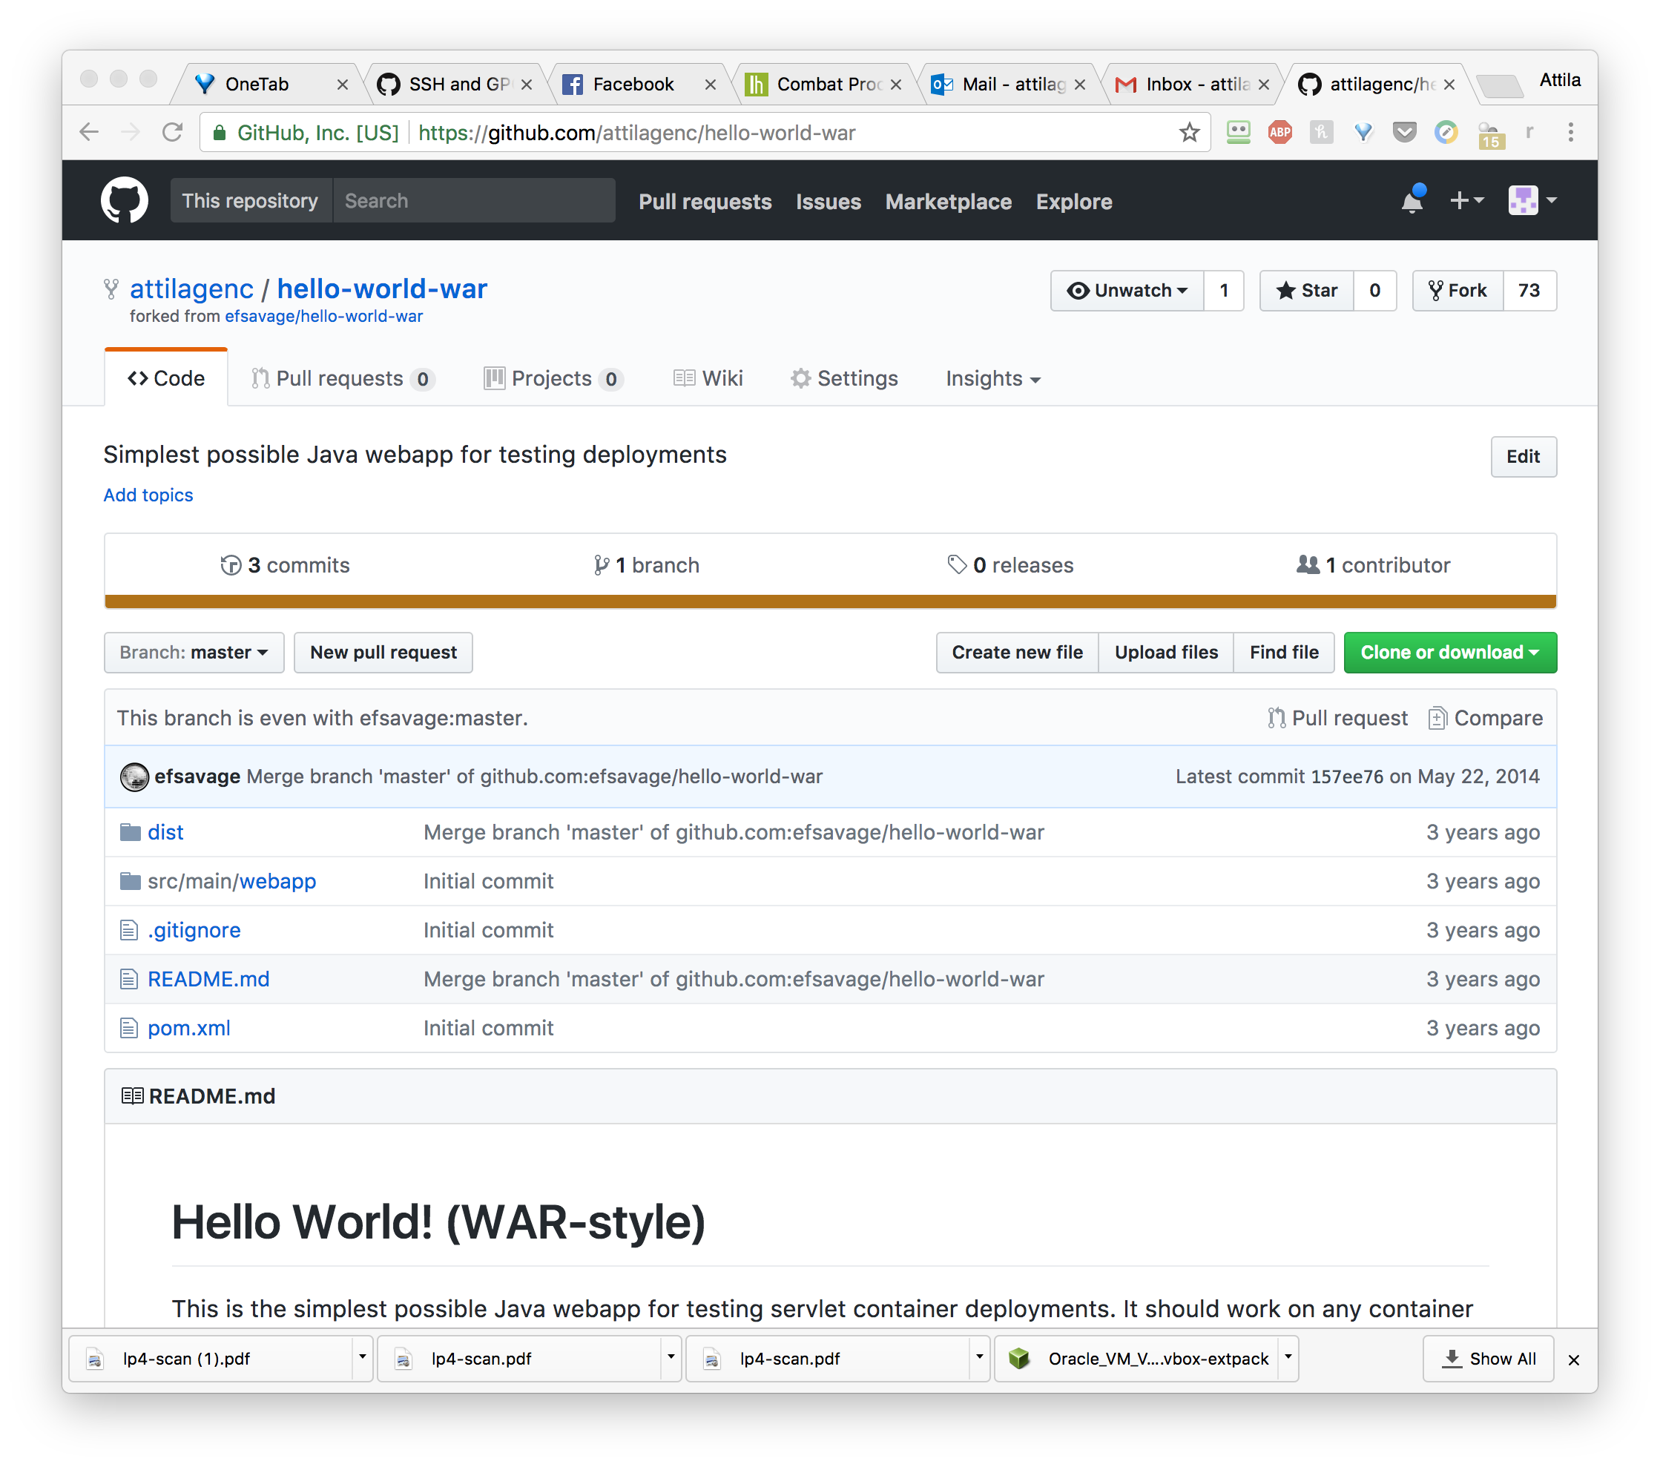

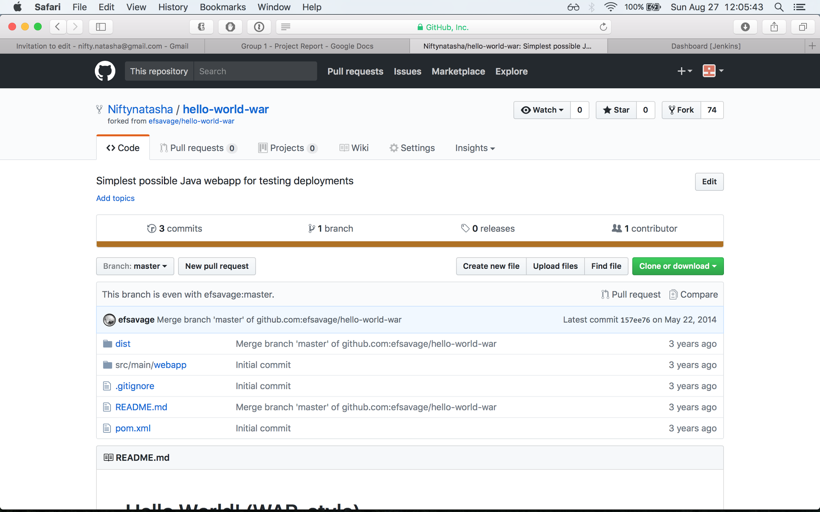

1. Create Dockerfile

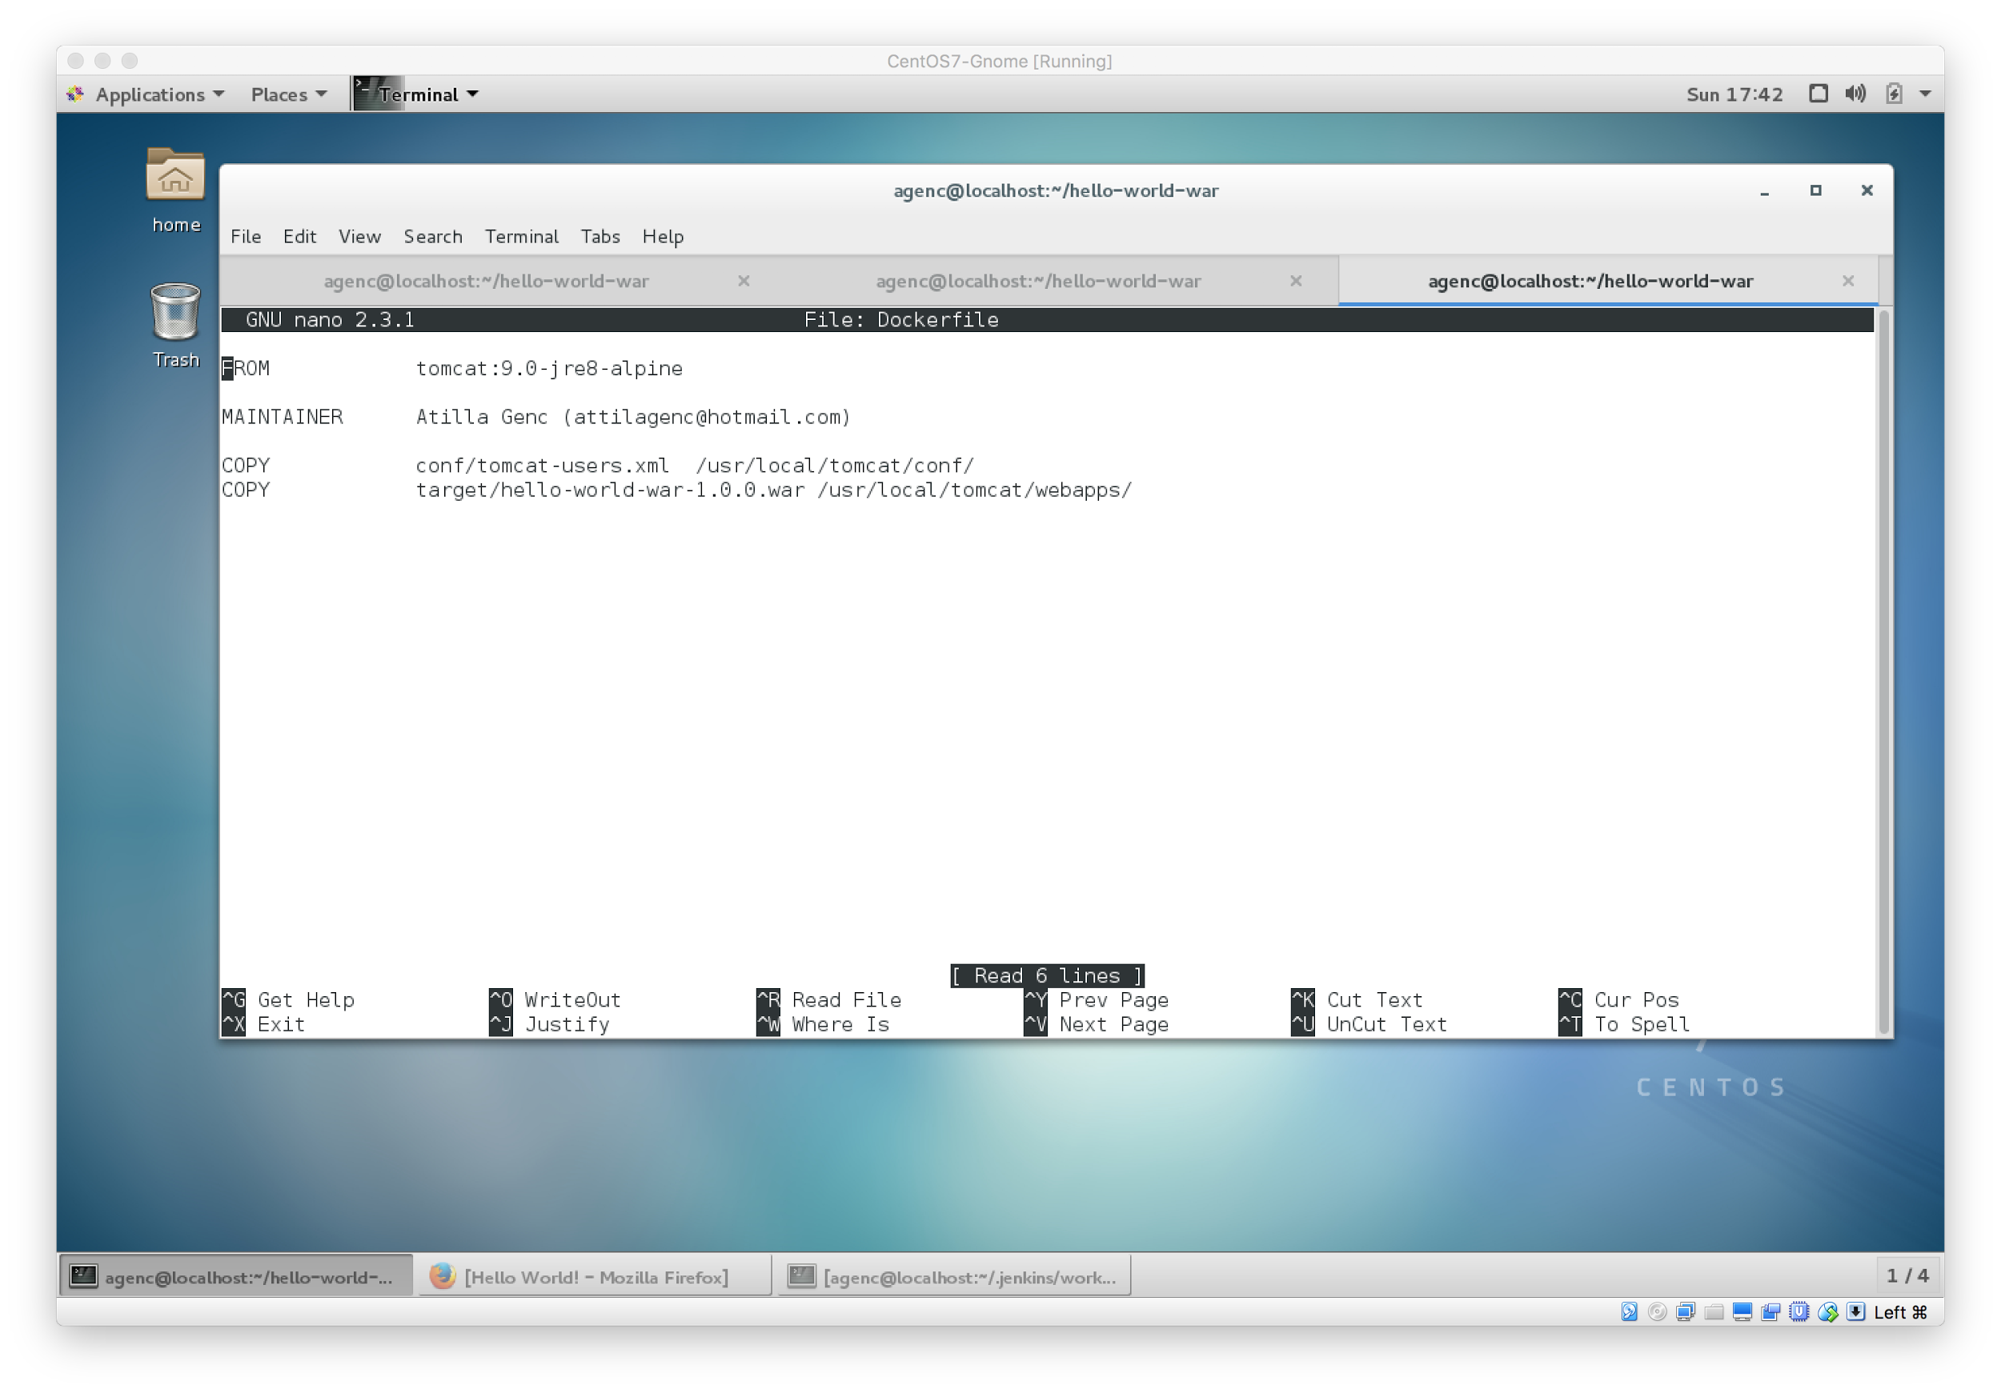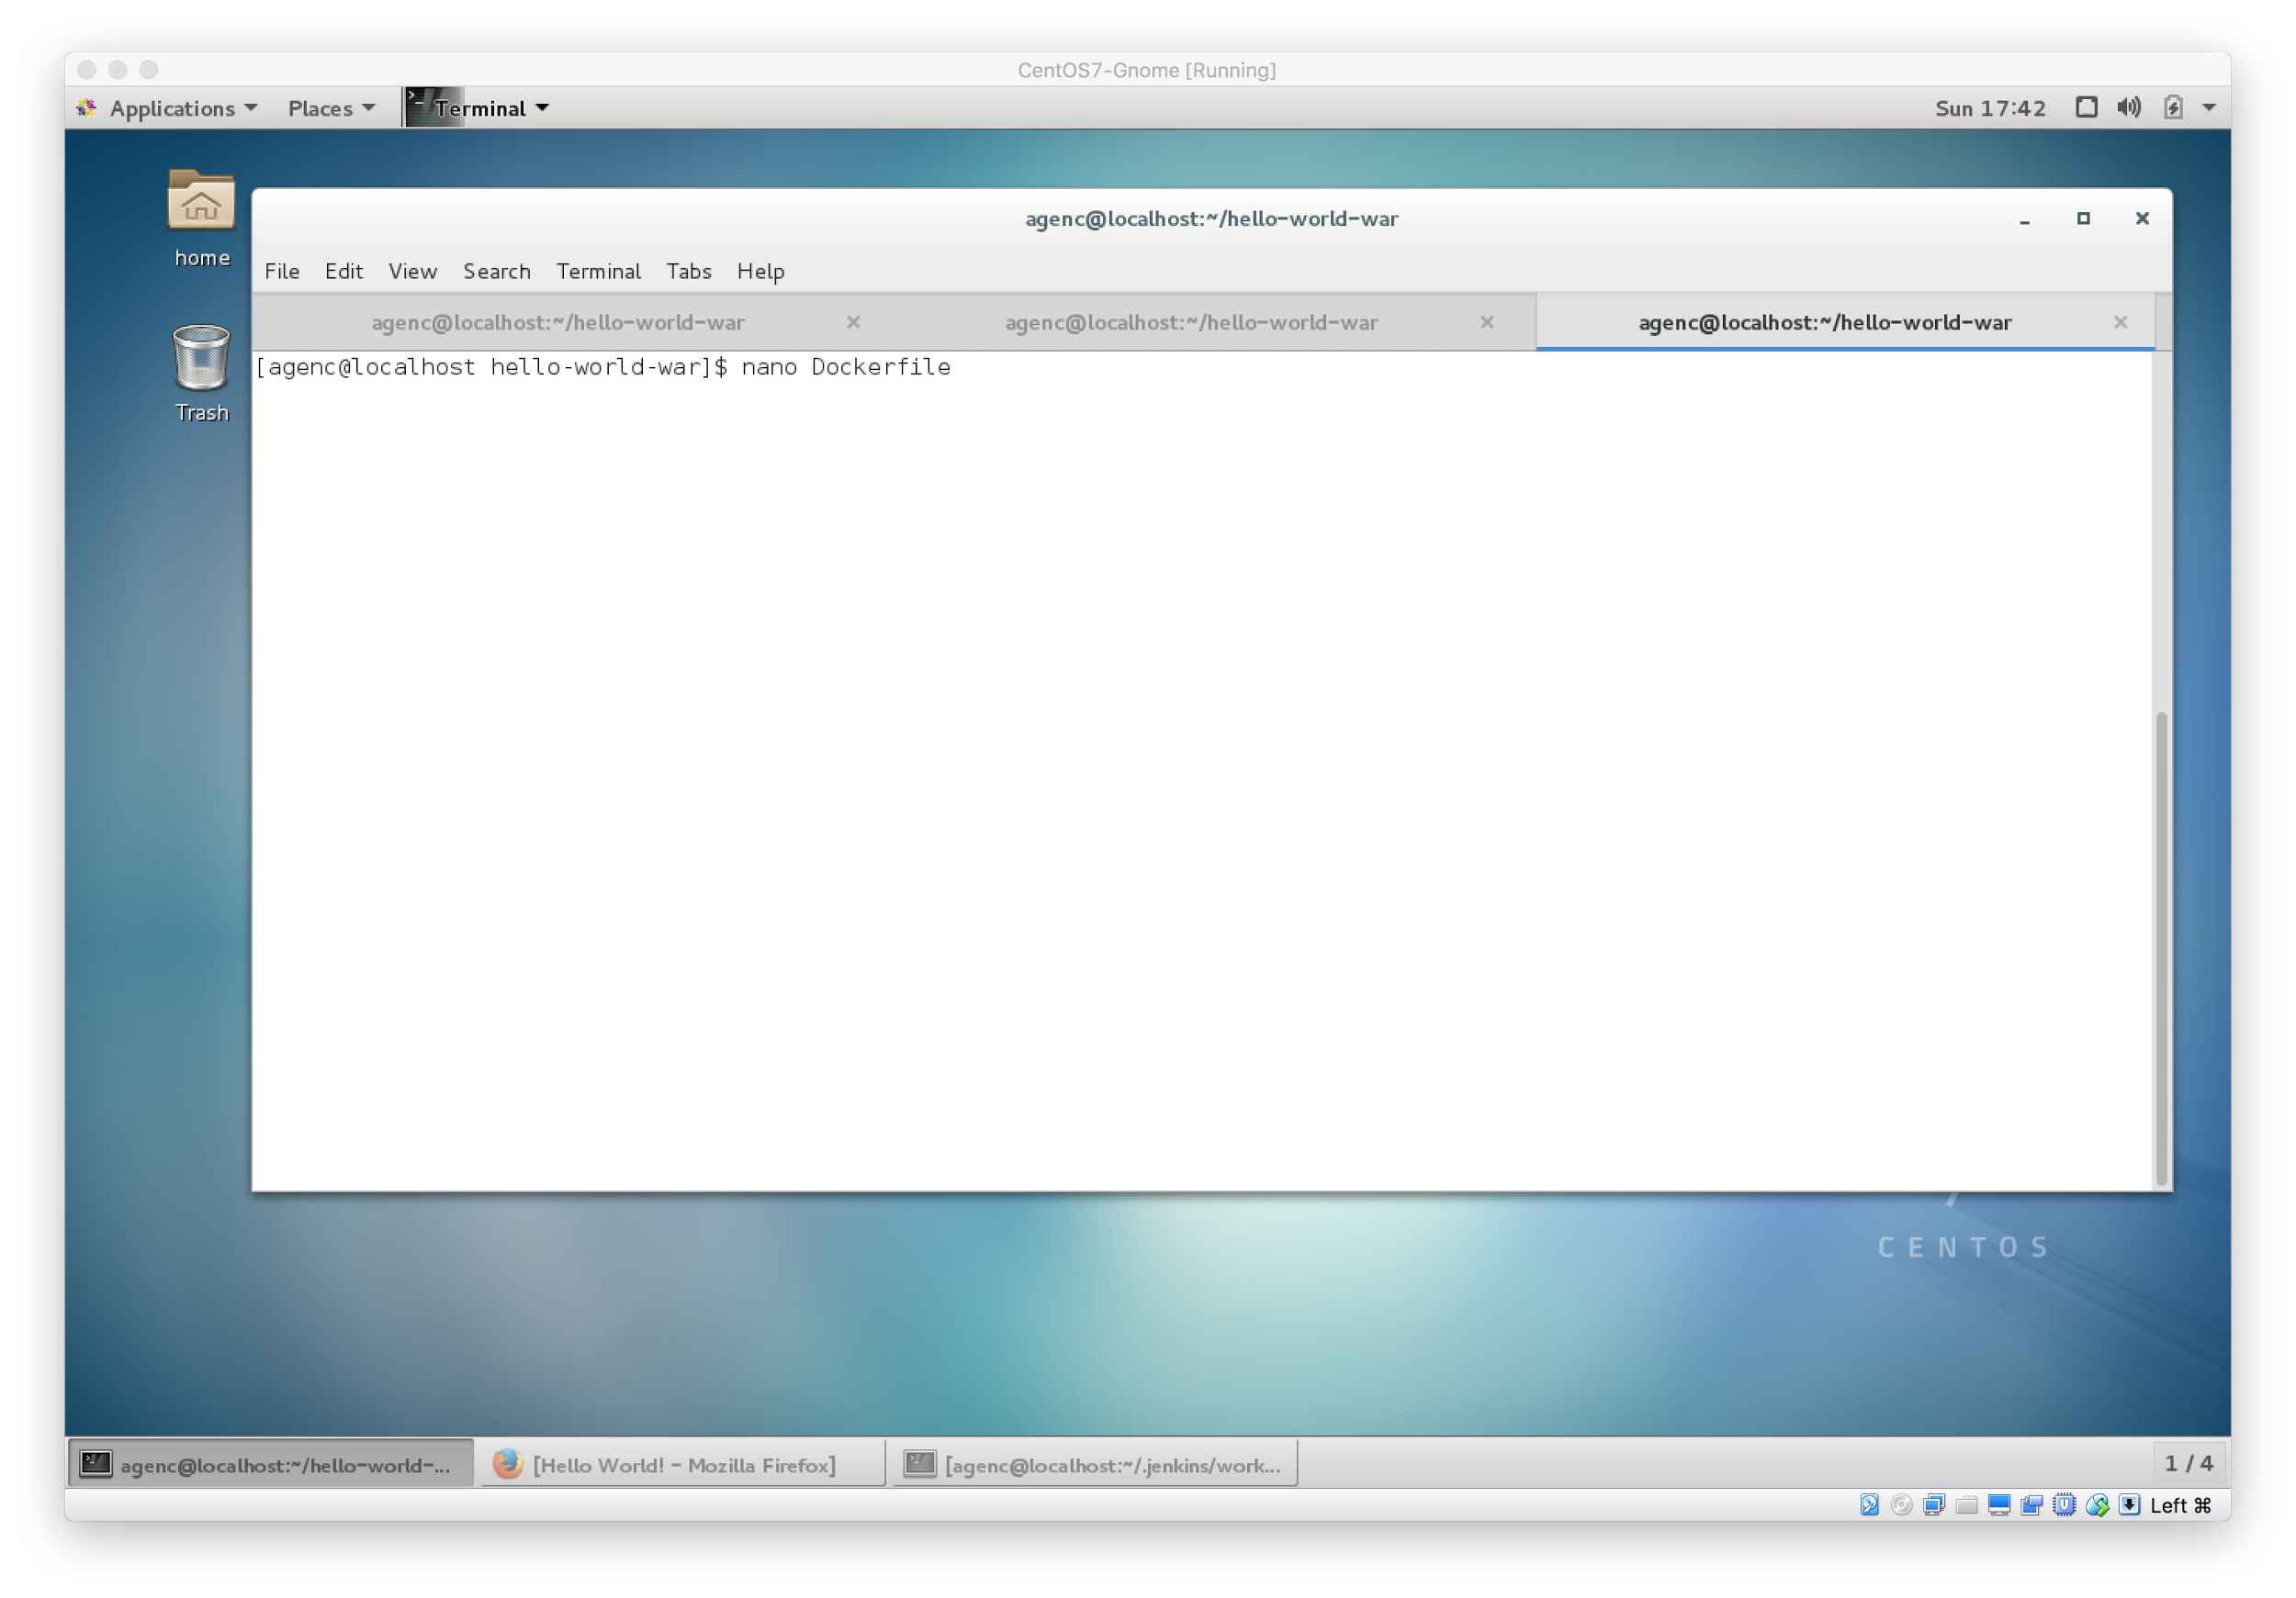

1. Push project to github

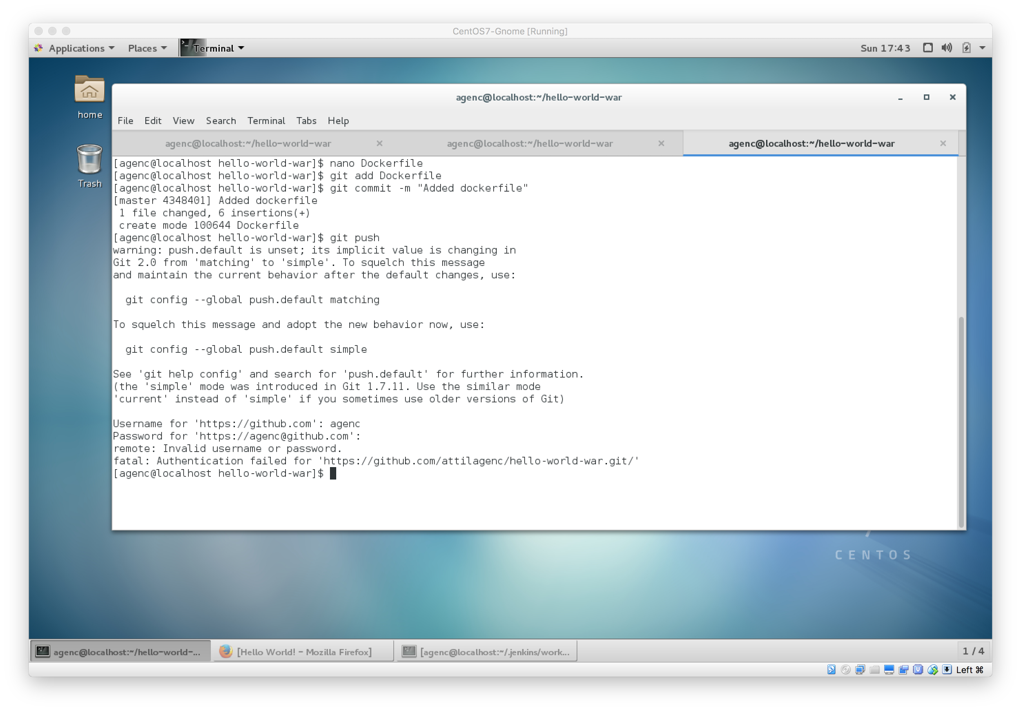

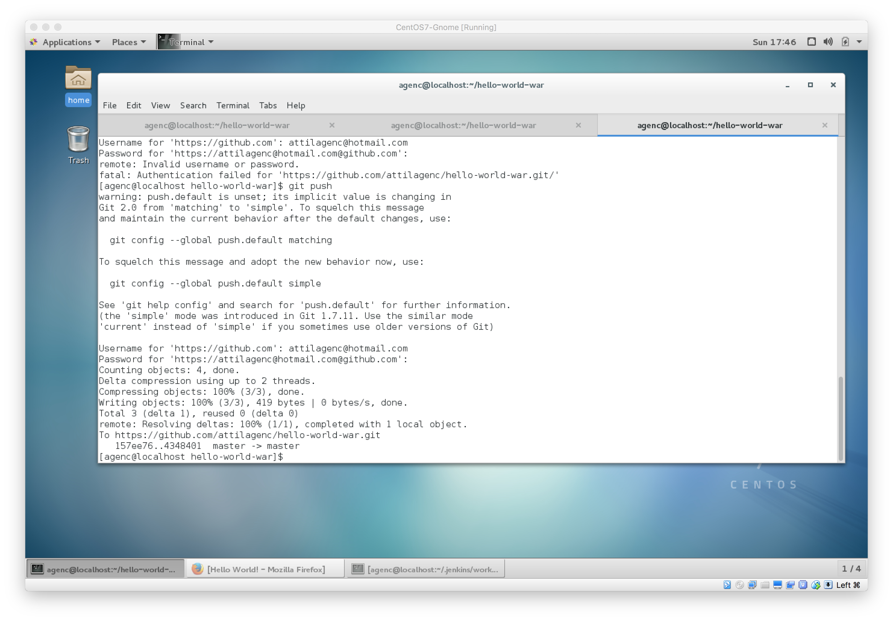

Set Up Continuous Integration Job in Jenkins

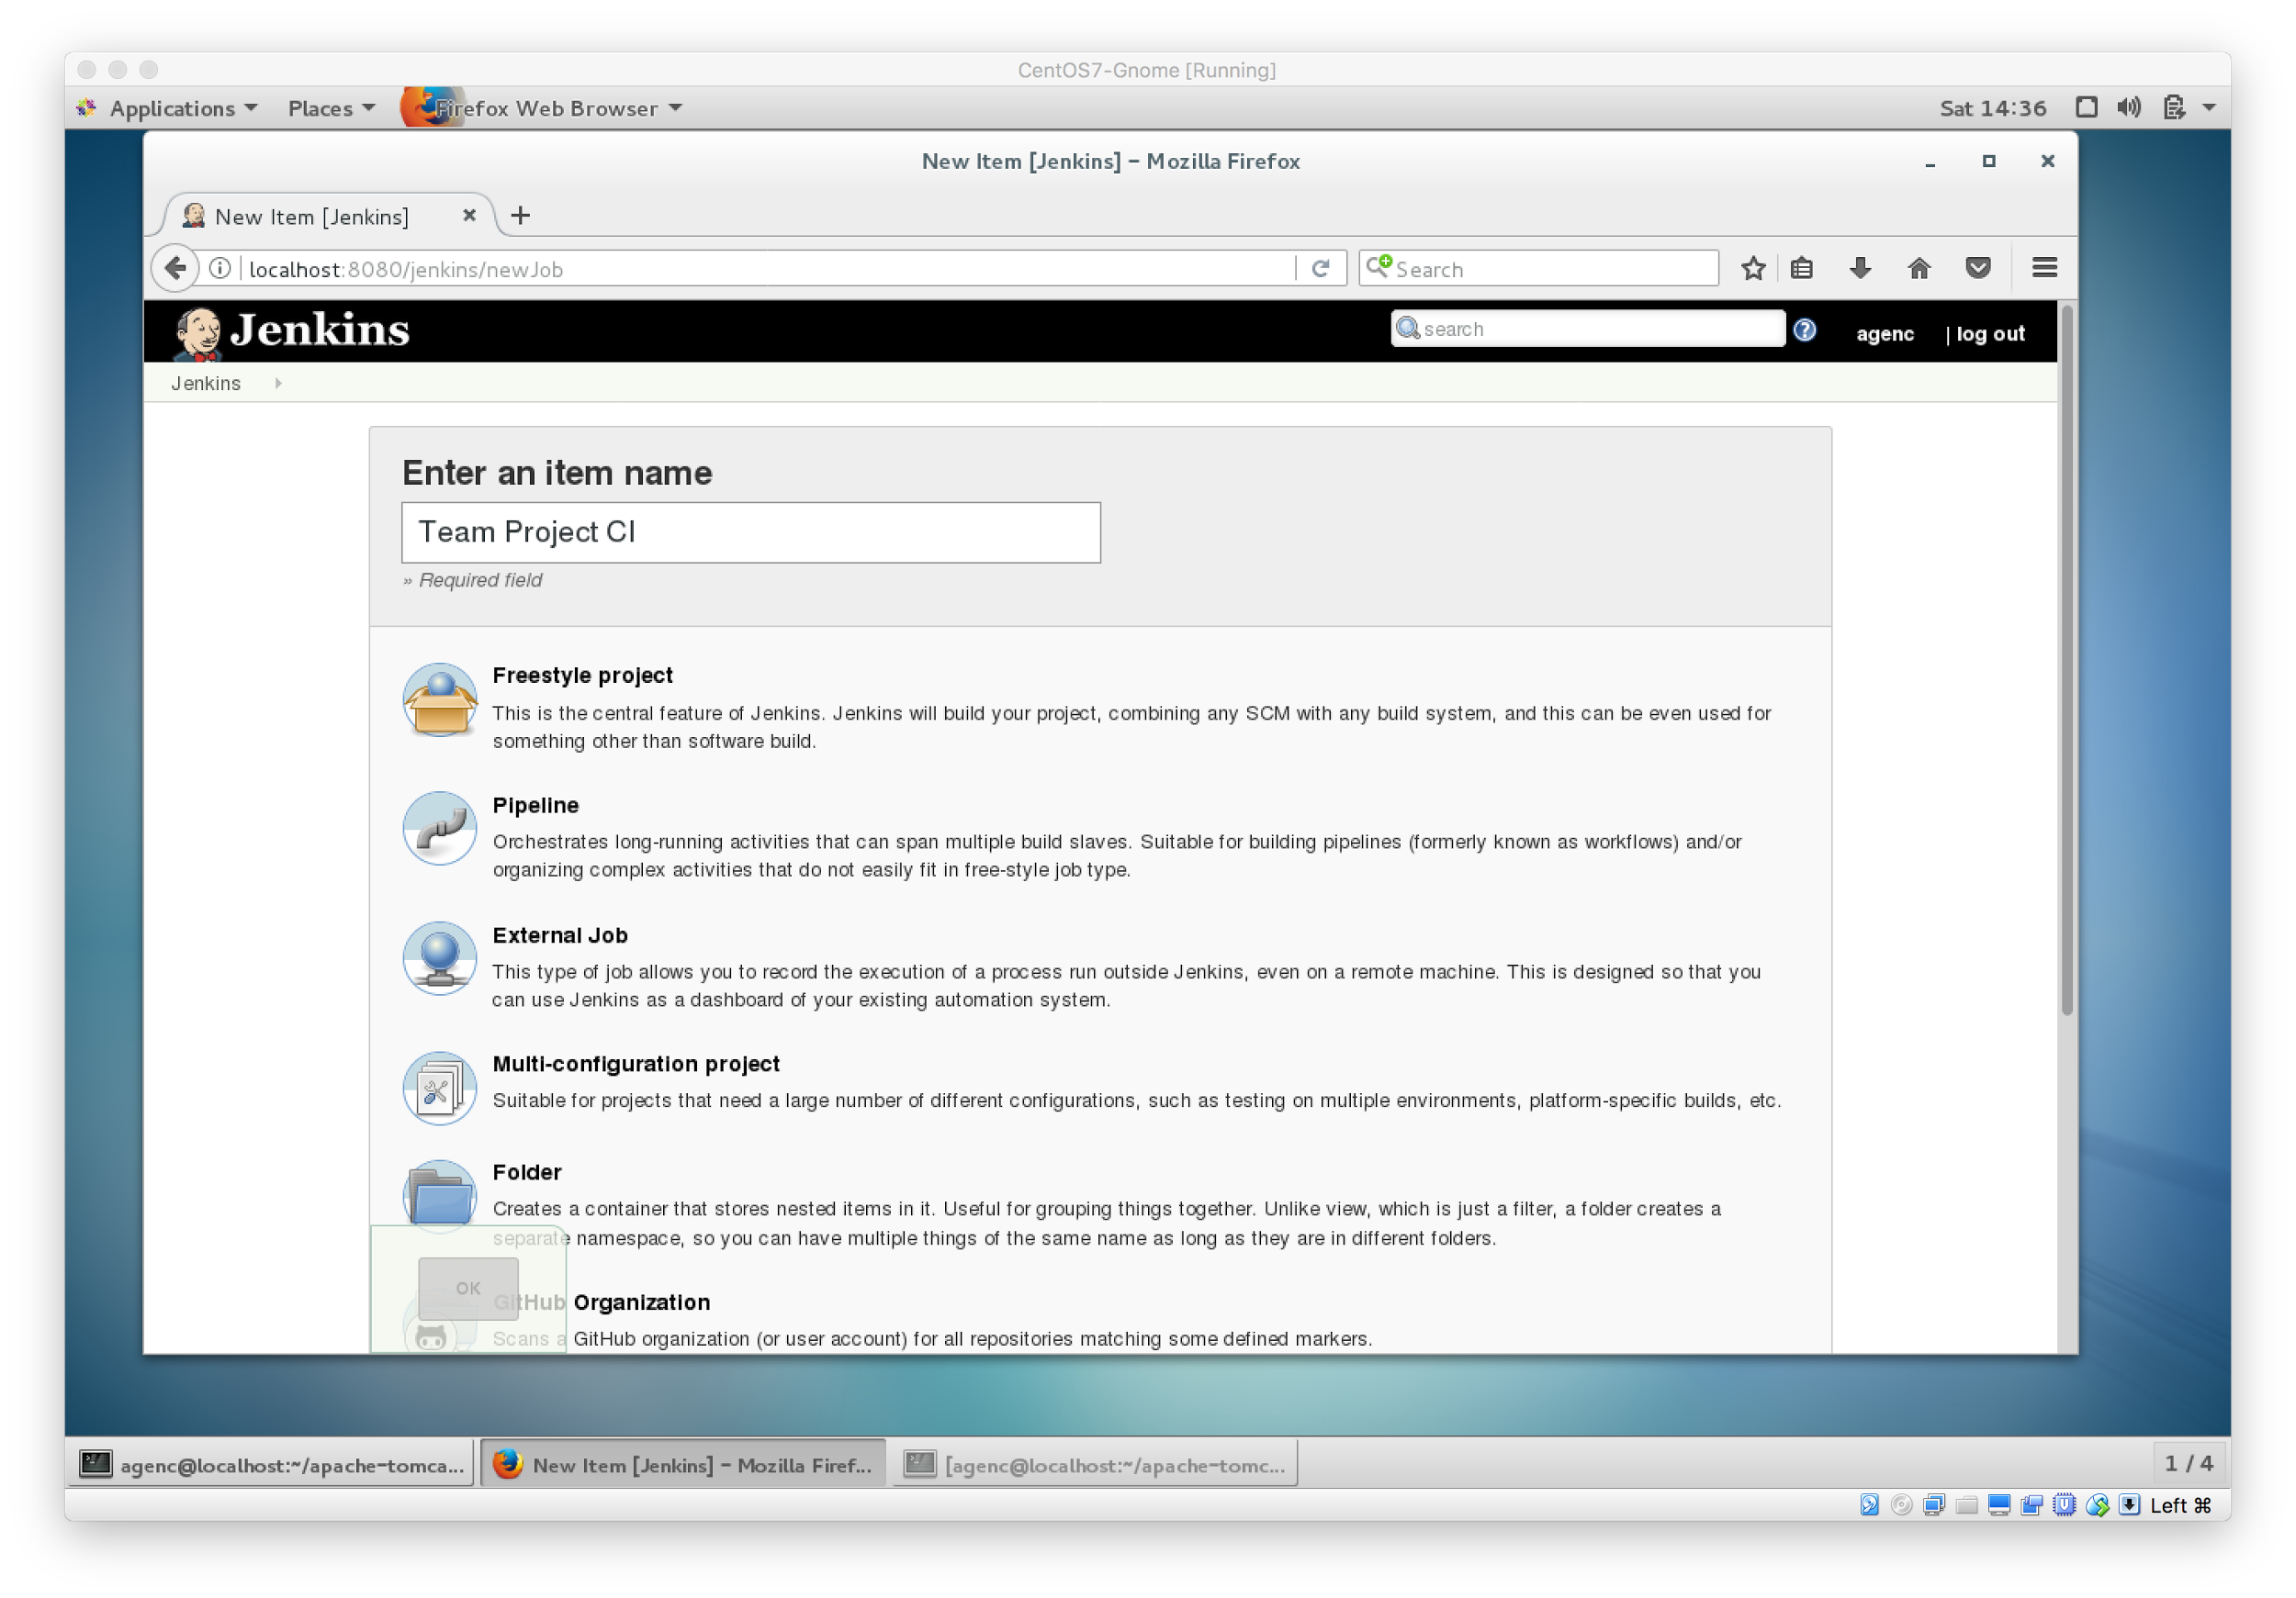

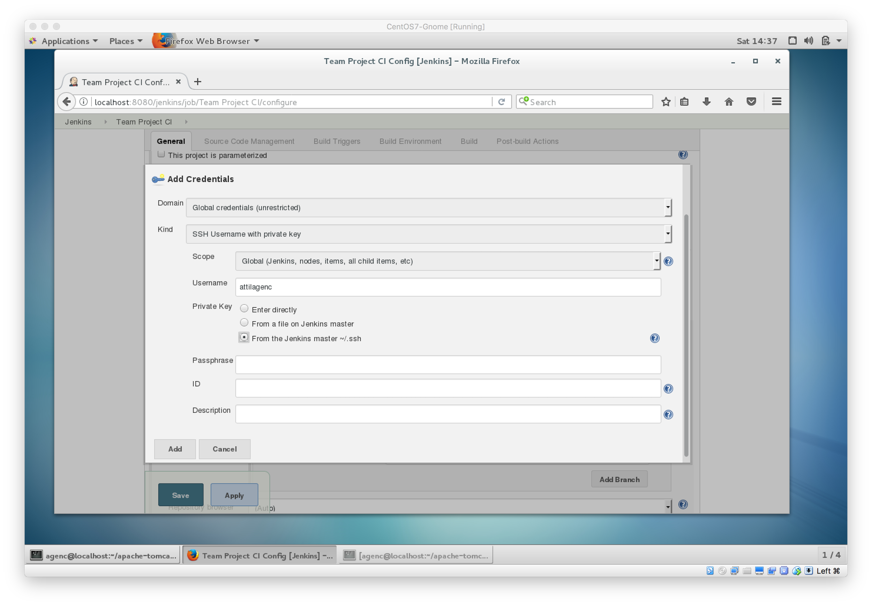

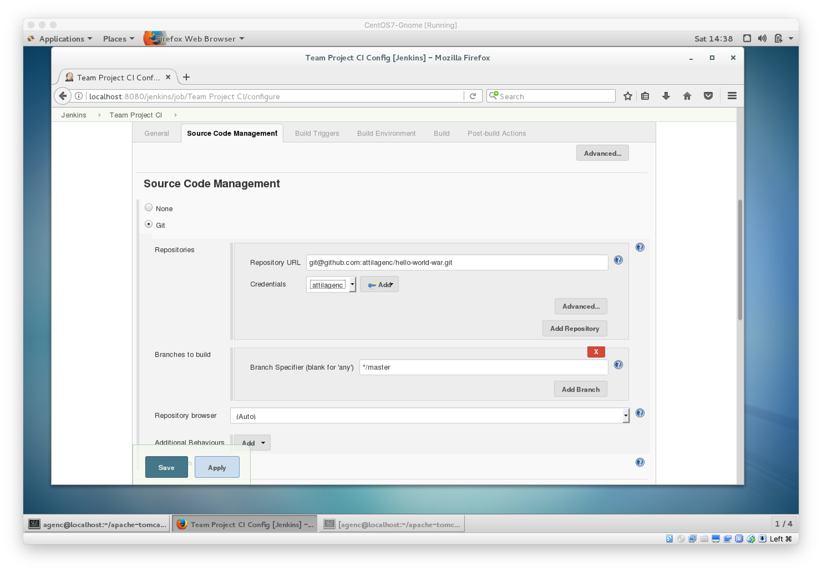

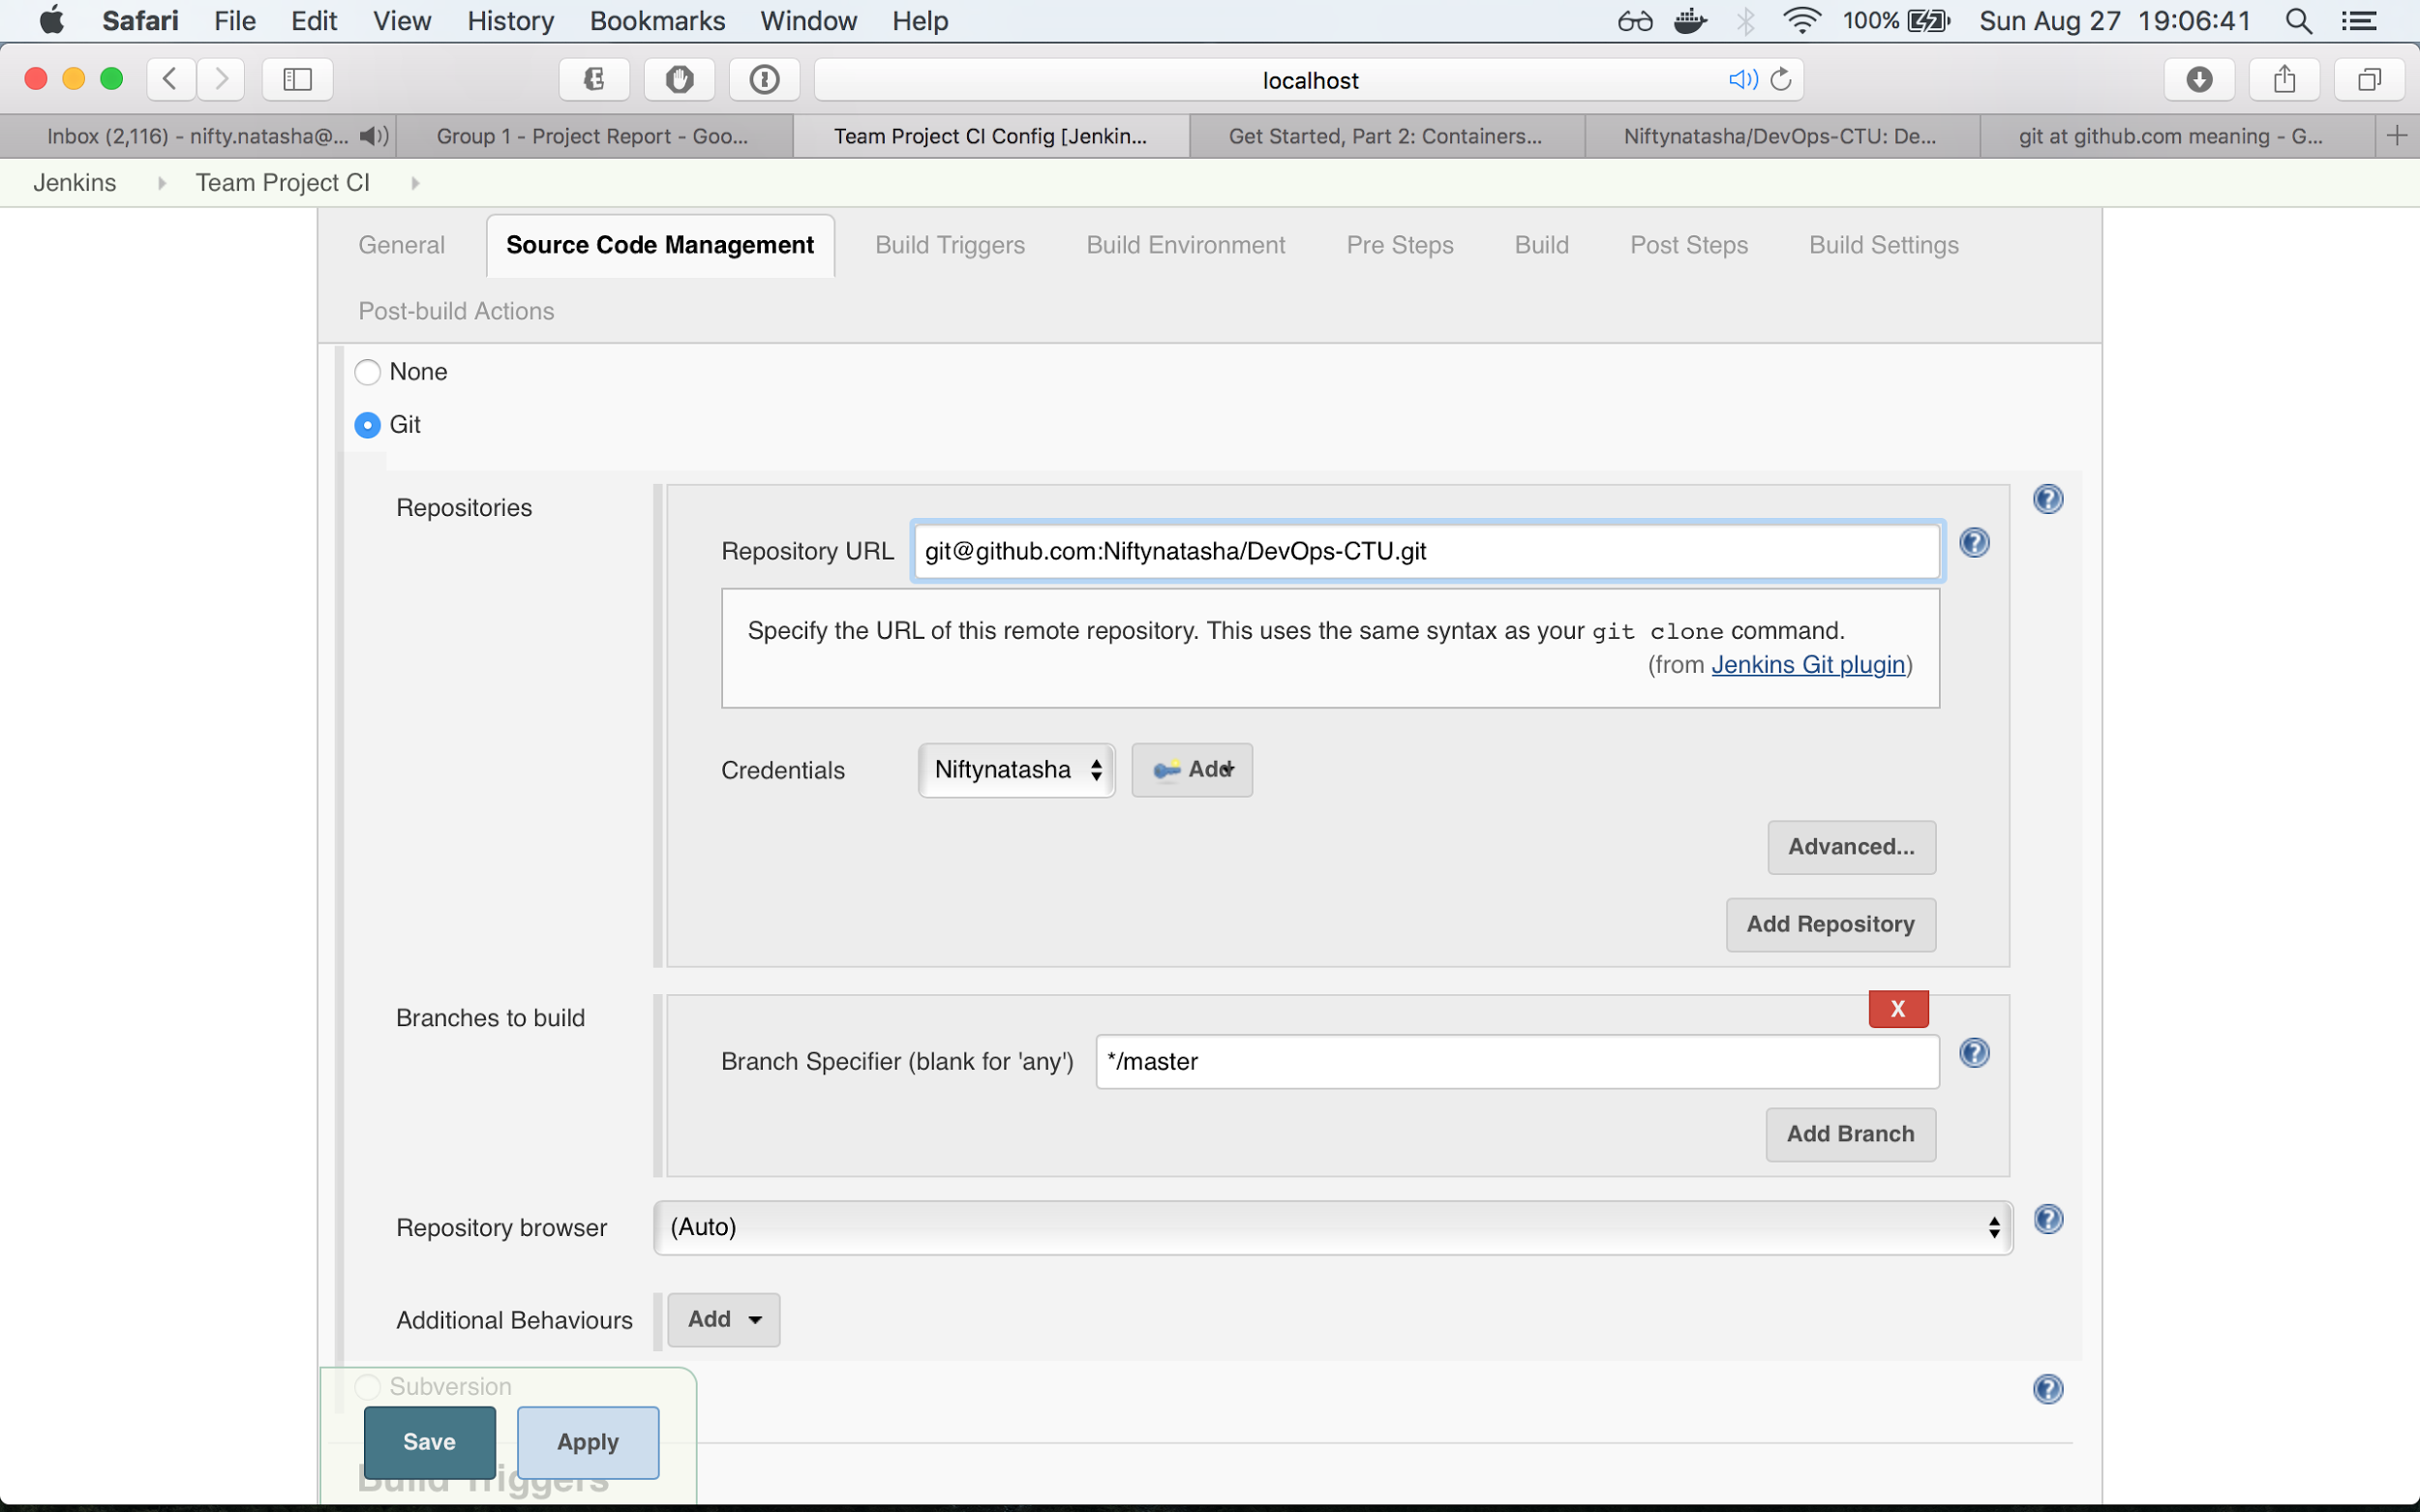

Setup Continuous Release Job in Jenkins

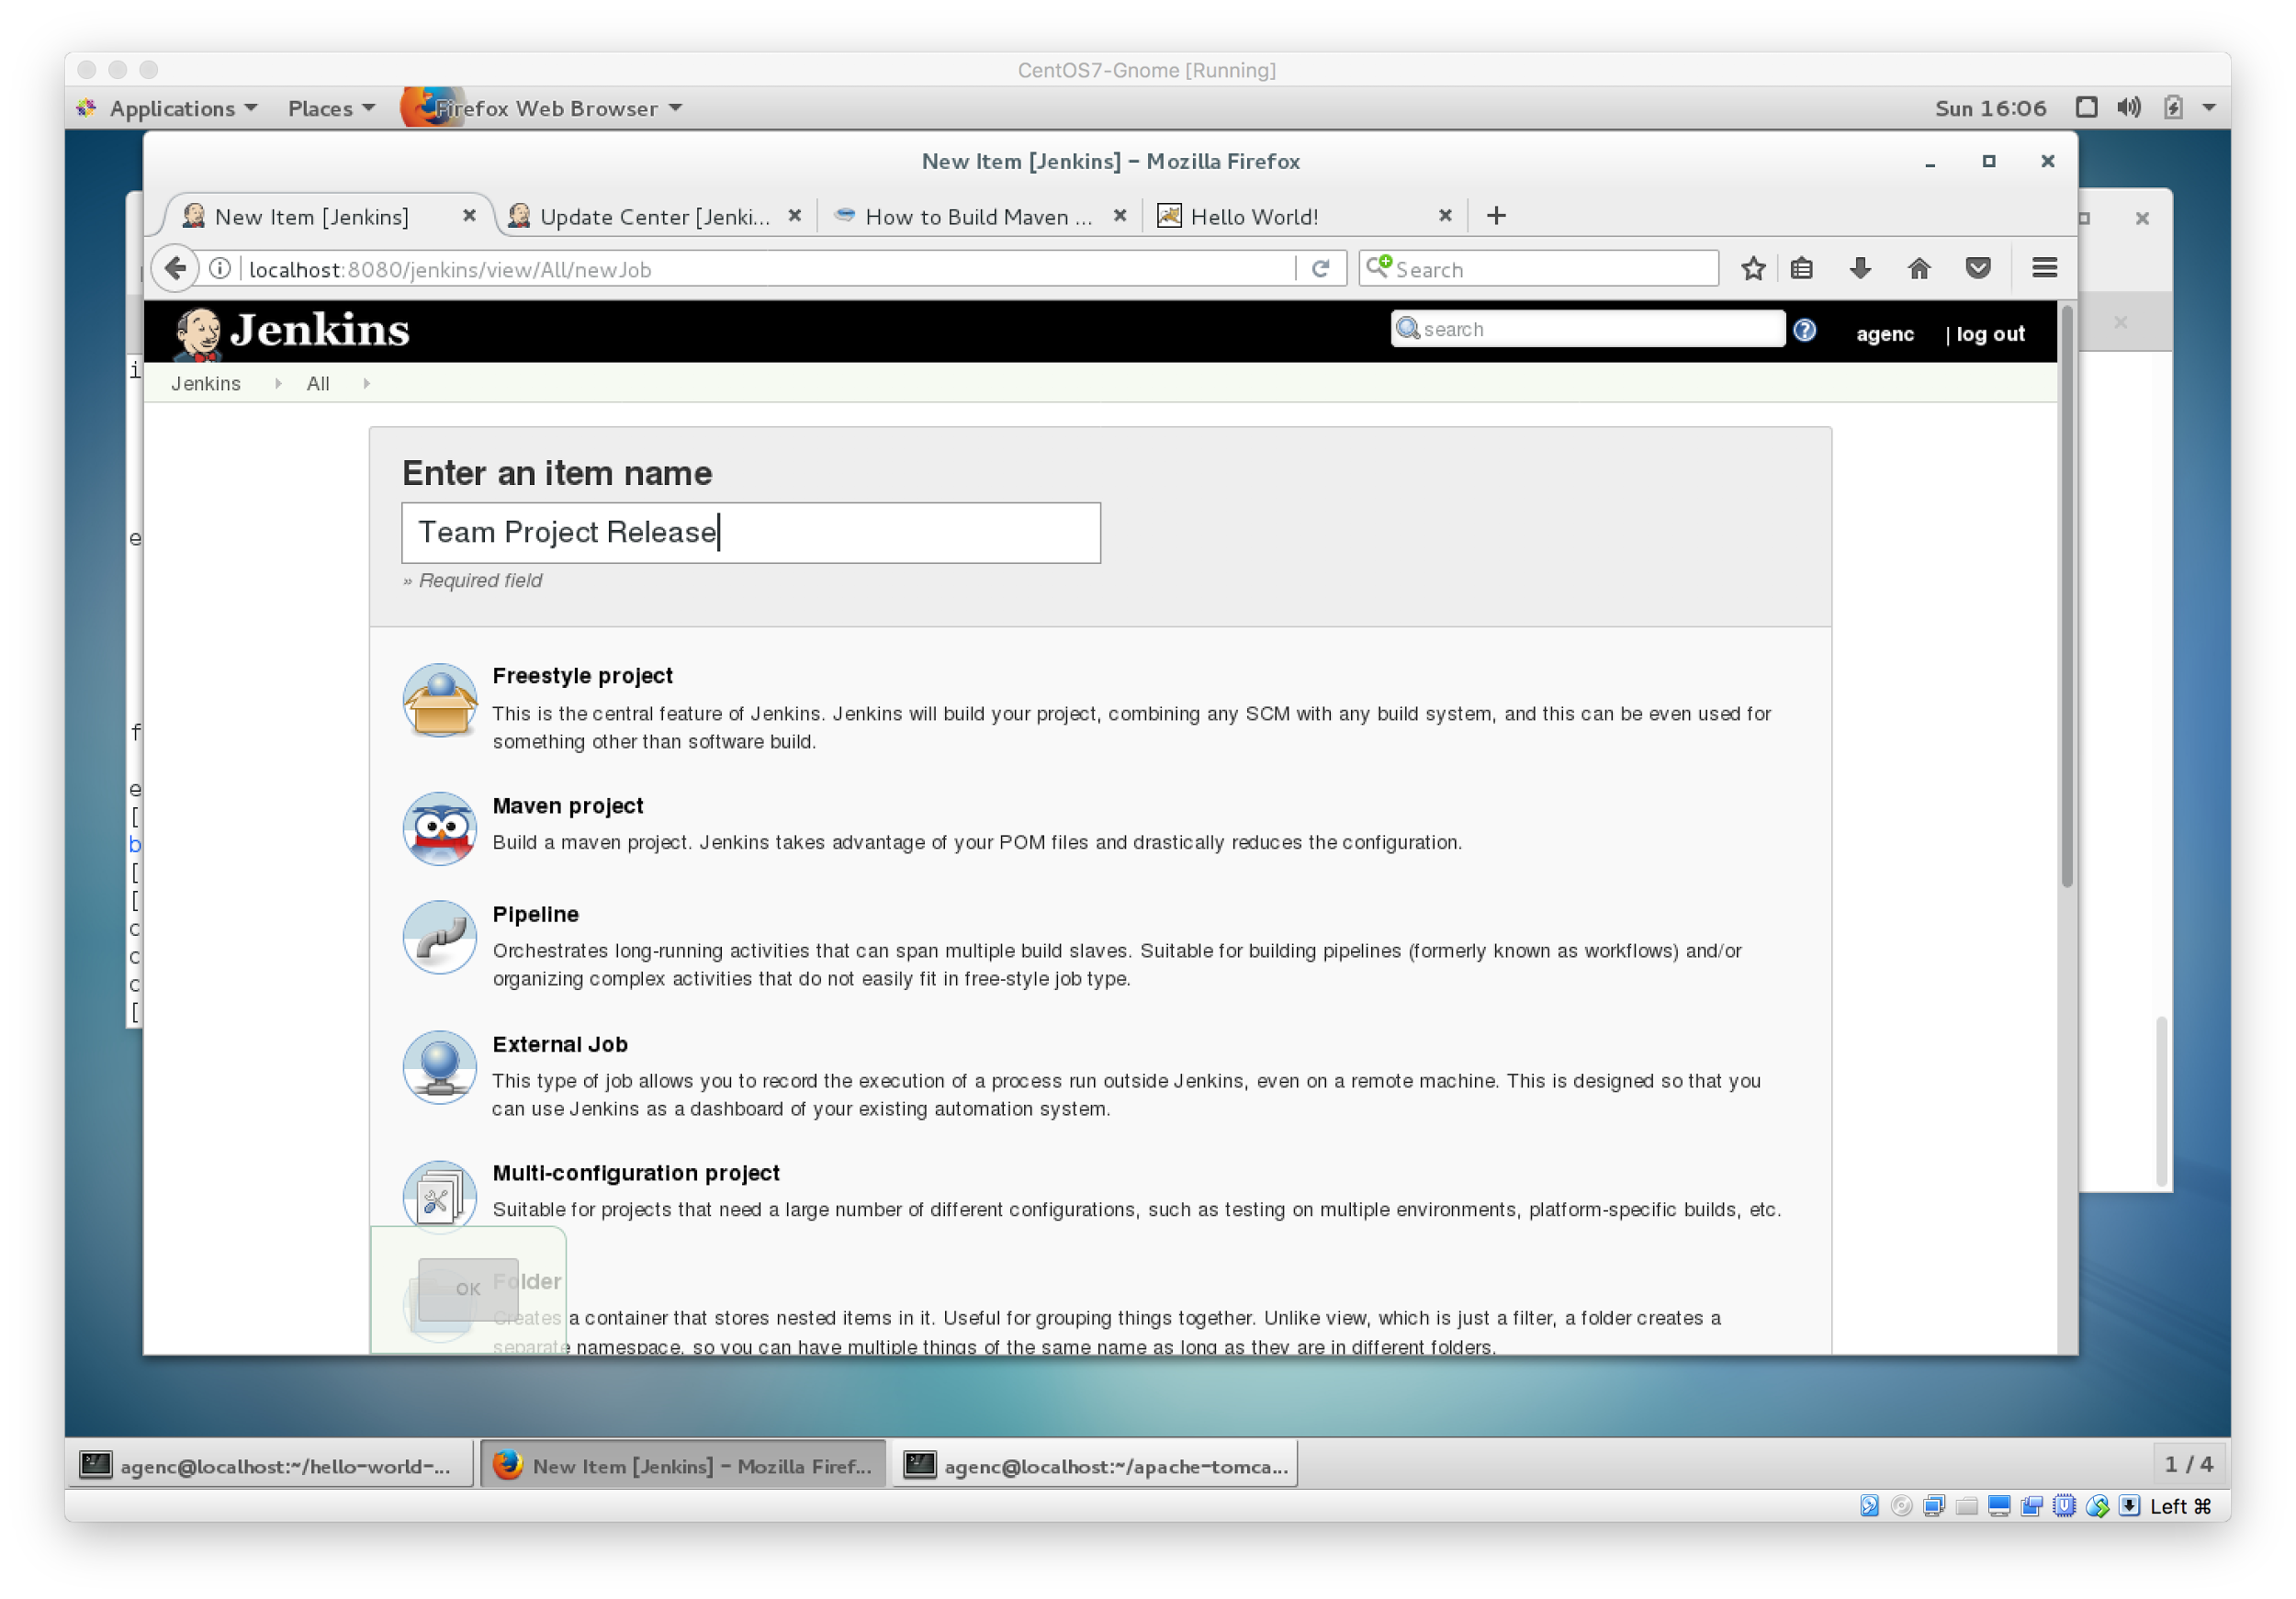

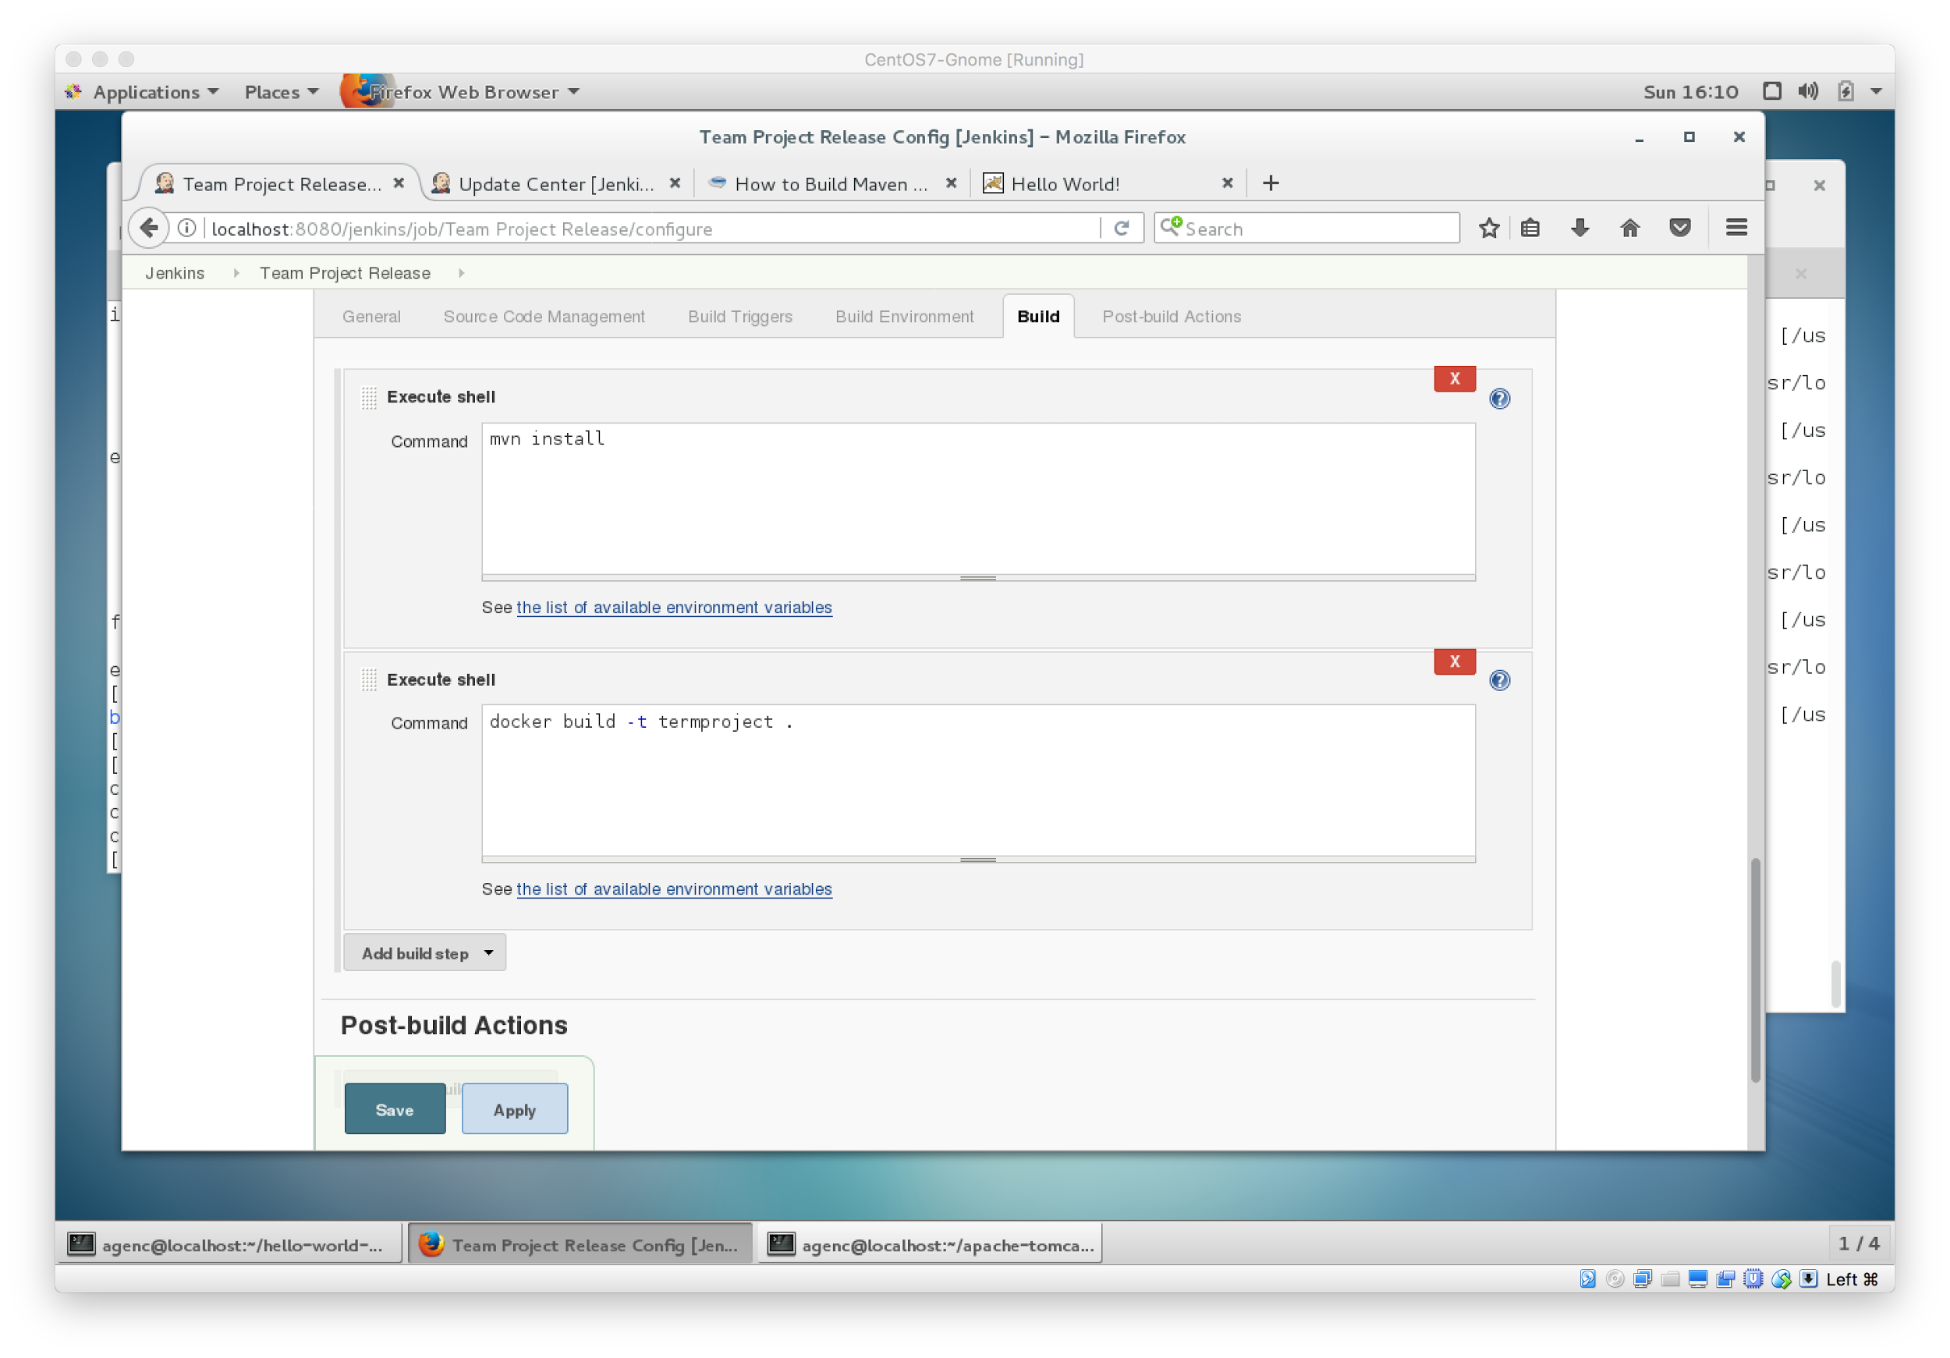

Setup Continuous Delivery Job in Jenkins

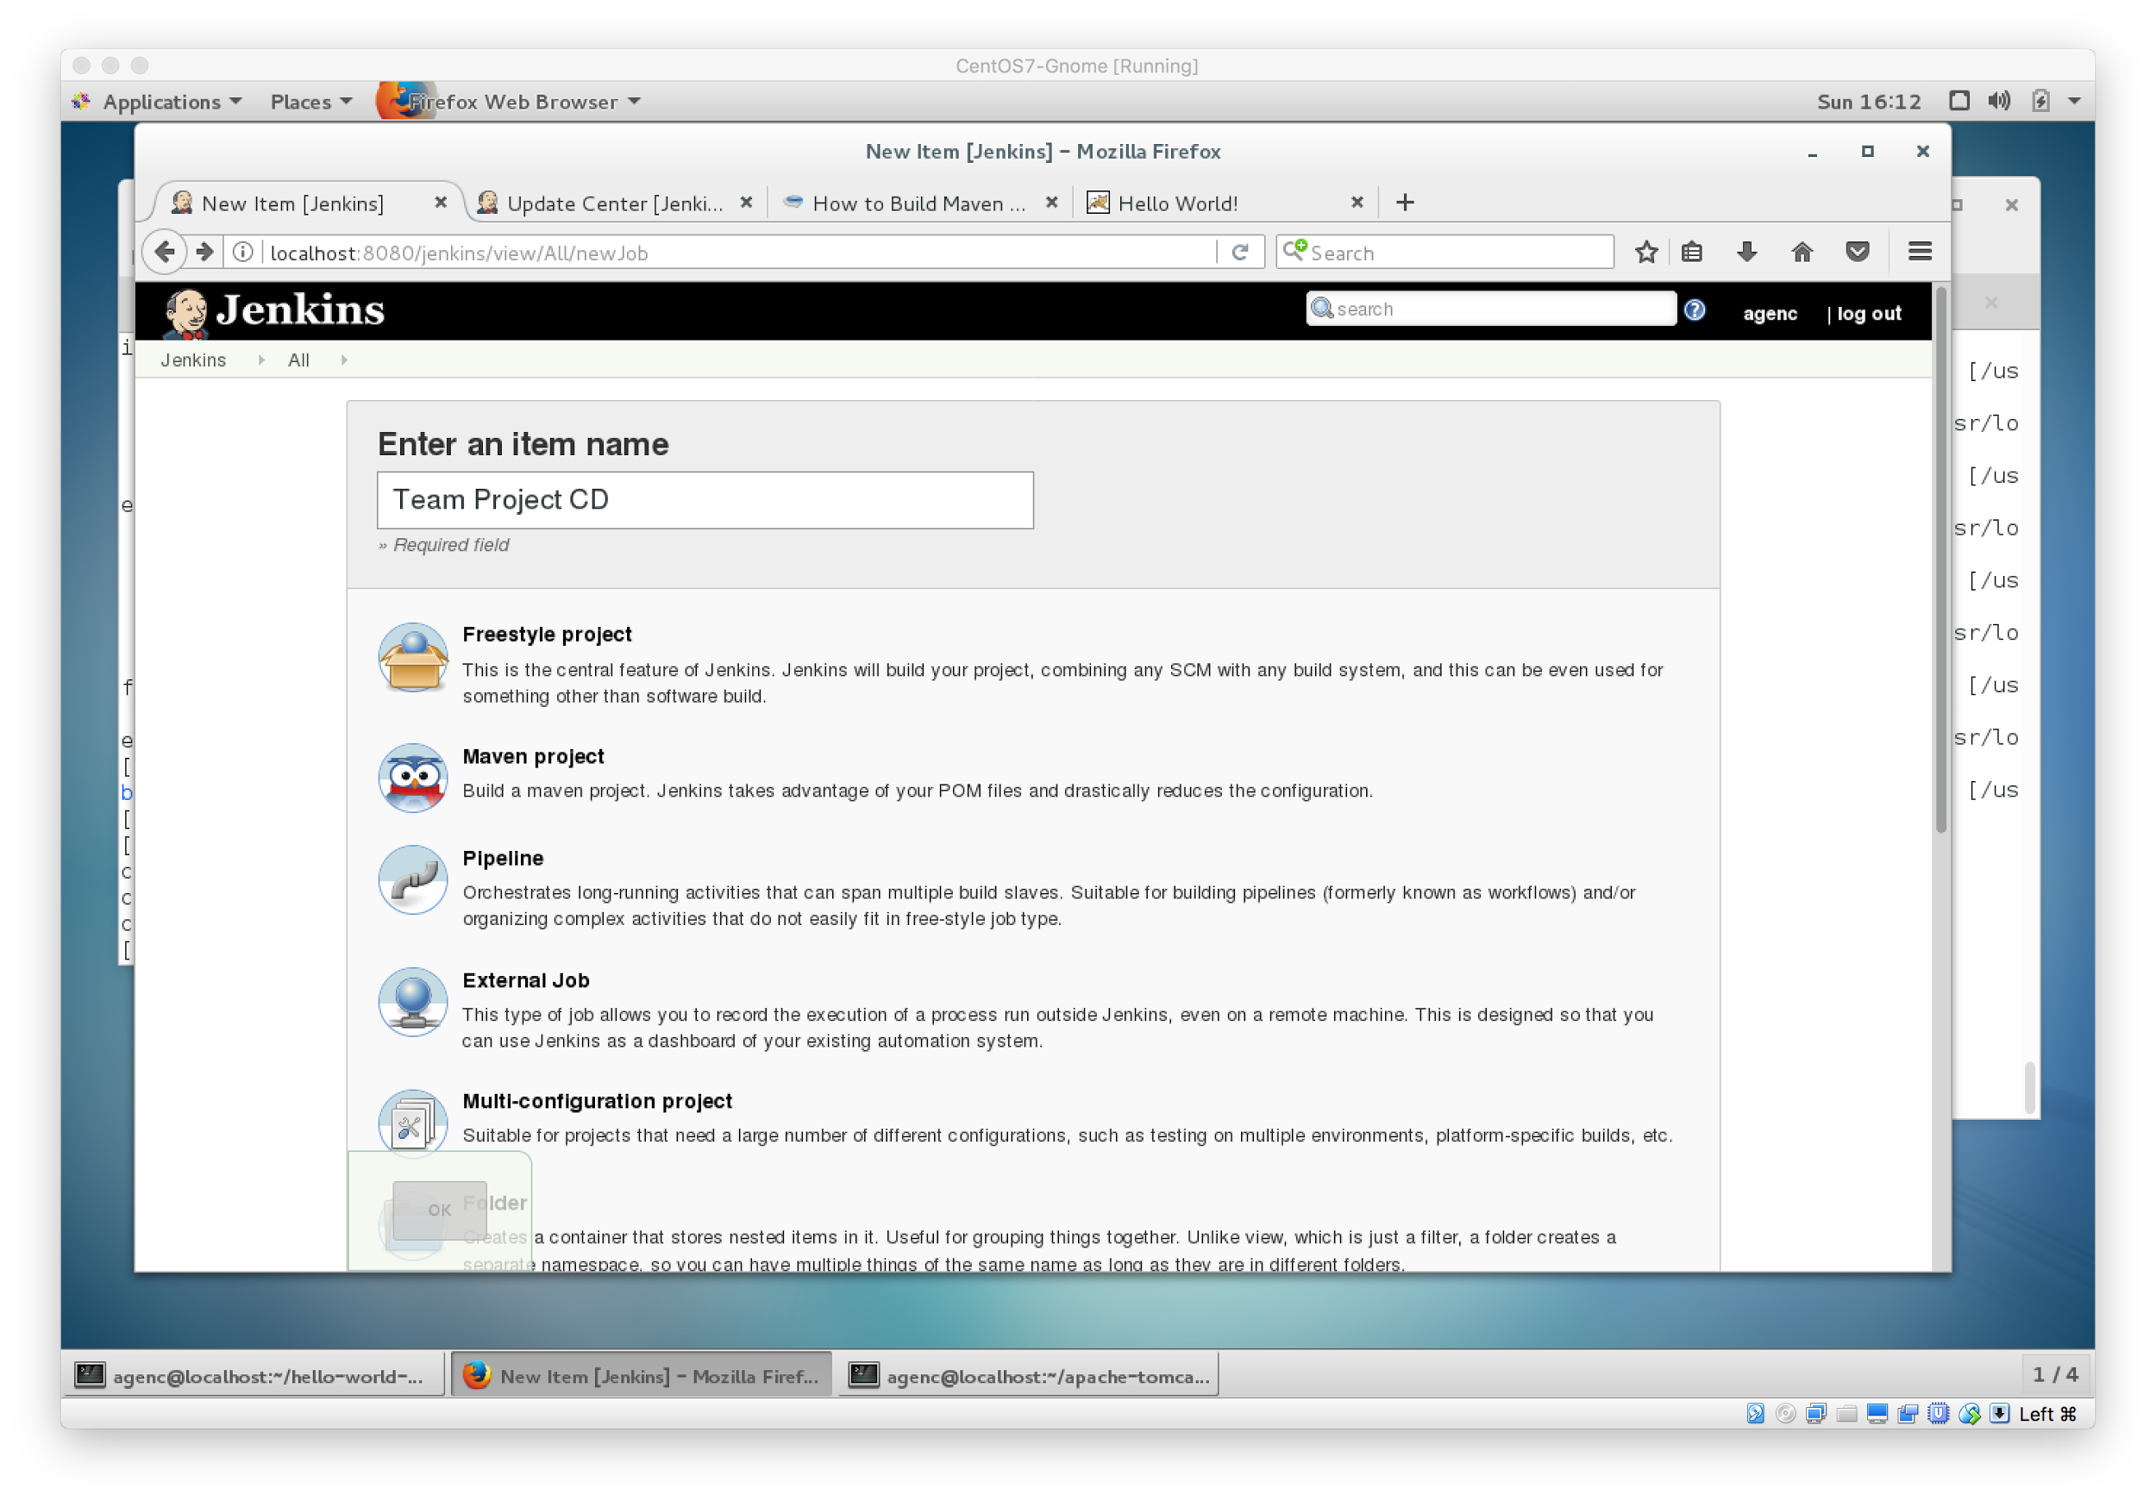

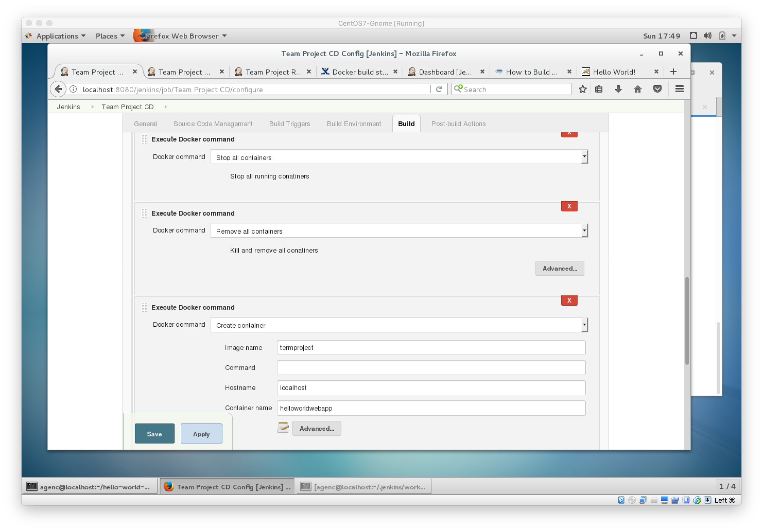

Jobs Created In Jenkins for continuous integration,release and delivery

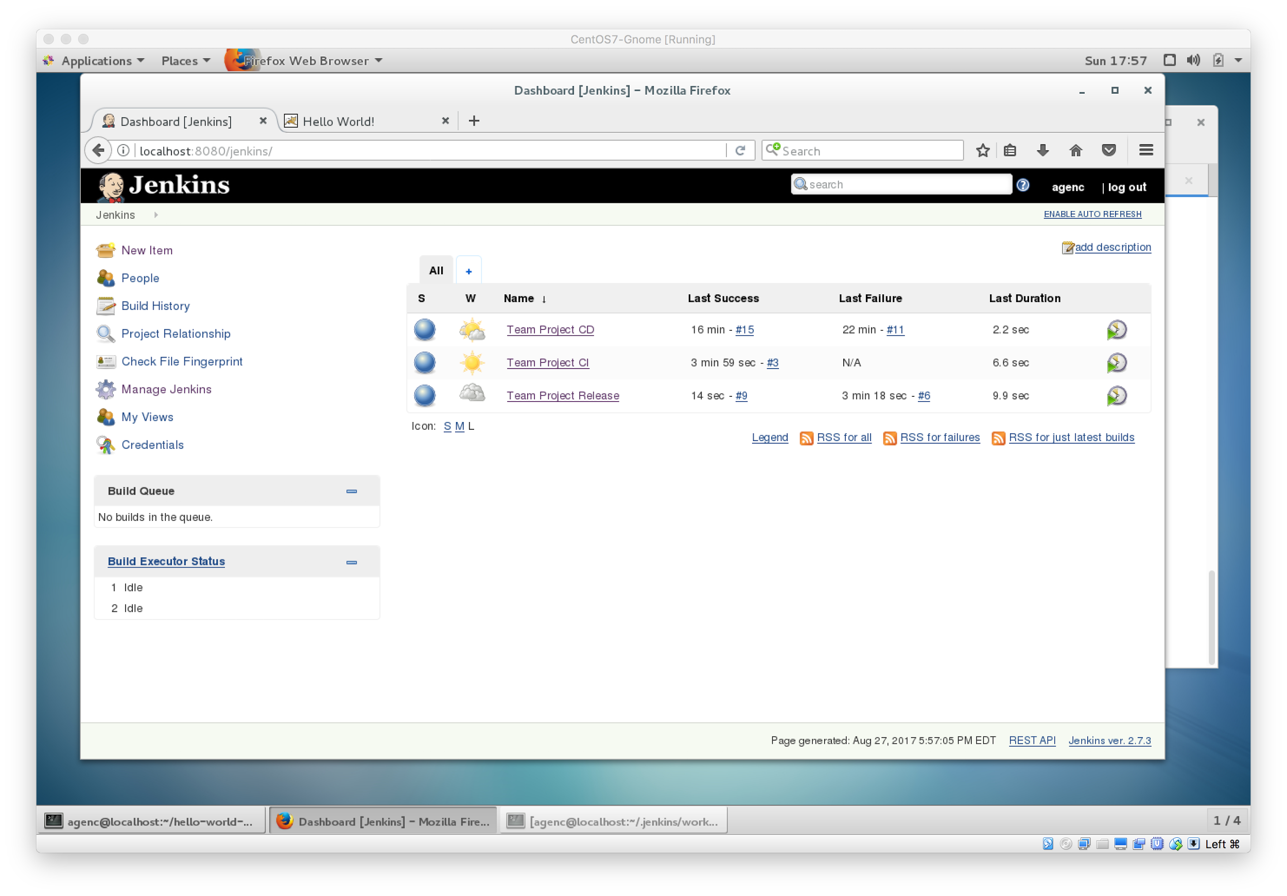

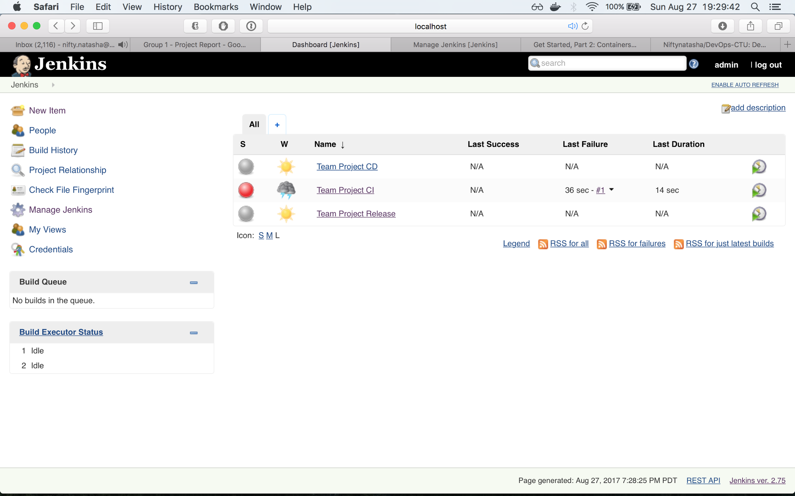

Sample Outputs from Job Runs

Sample Output from Continuous Integration Job

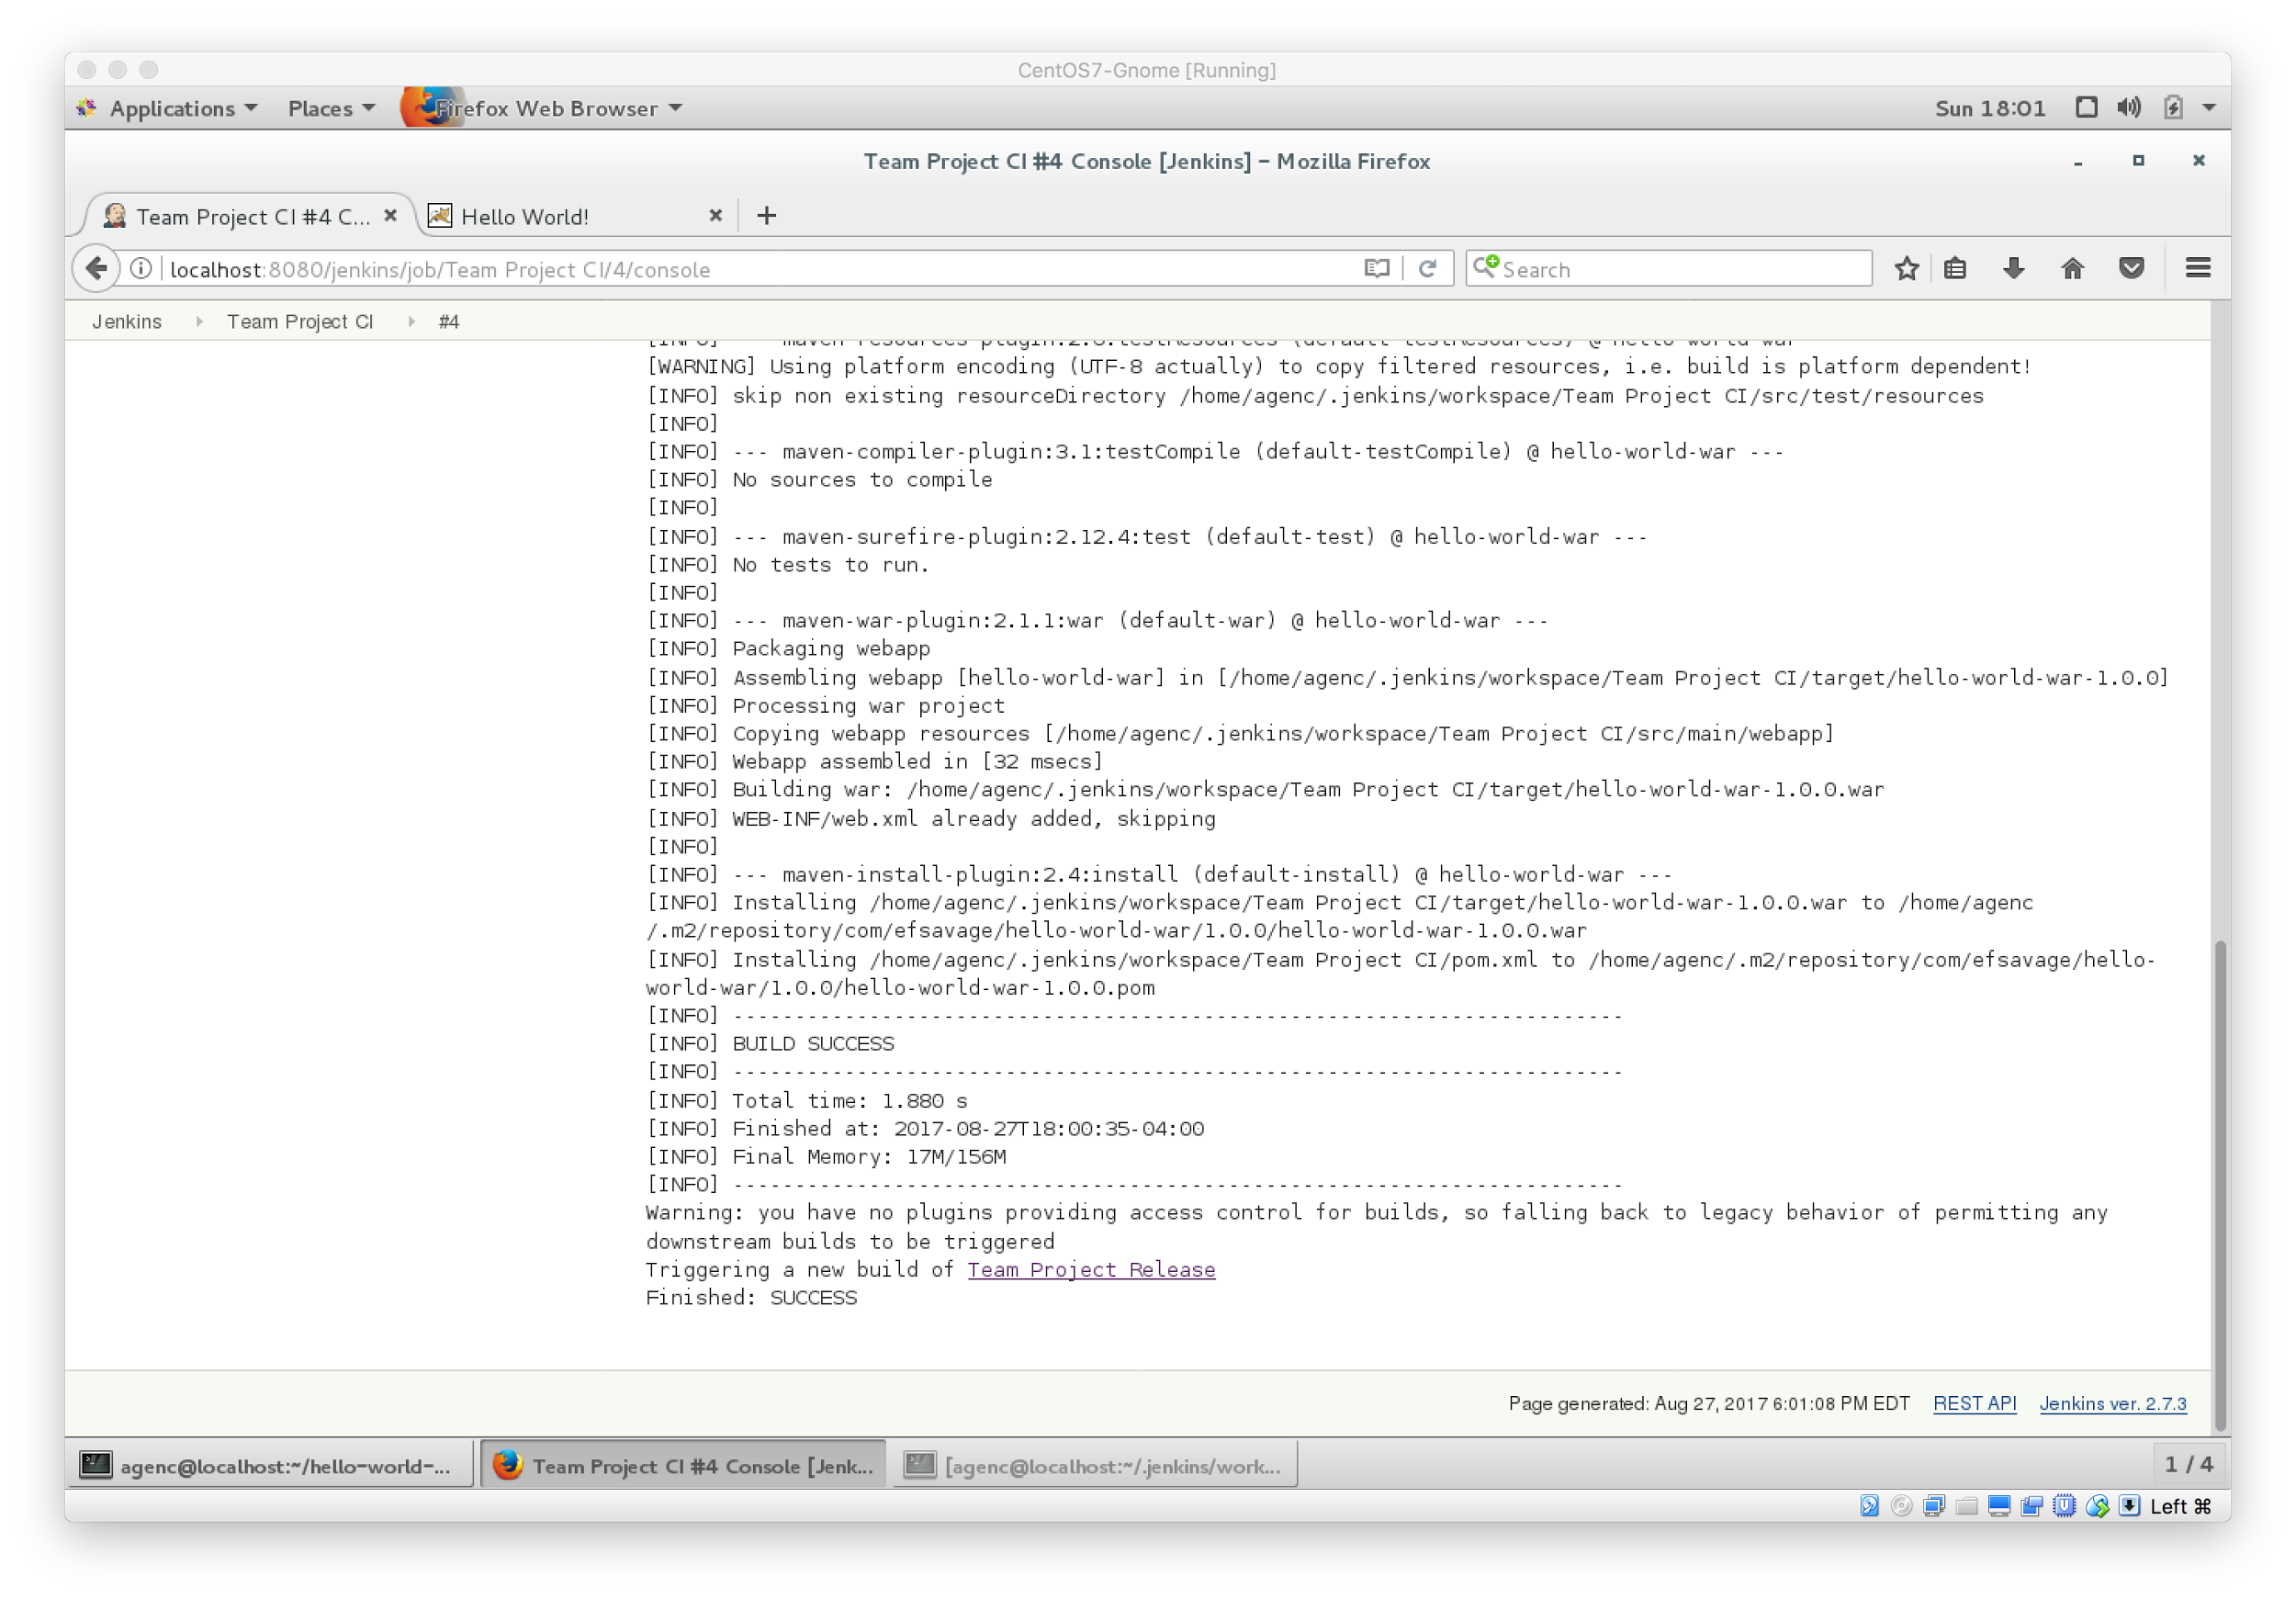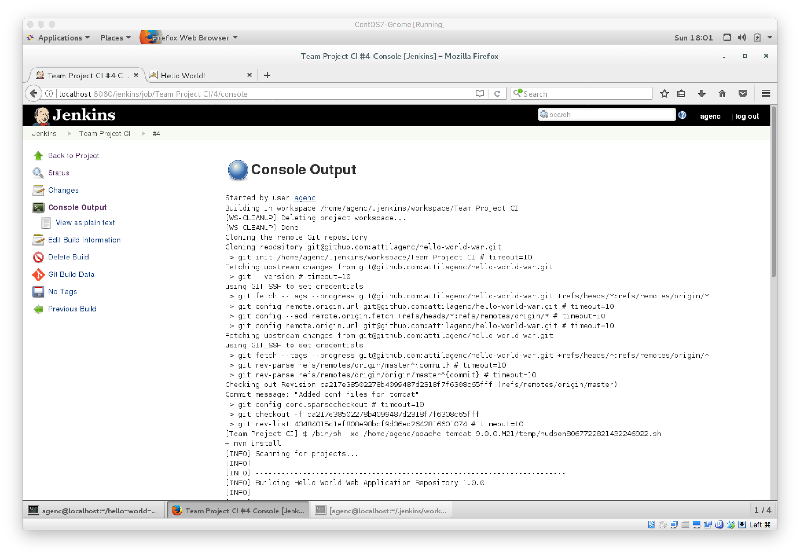

Sample Output from Continuous Release Job

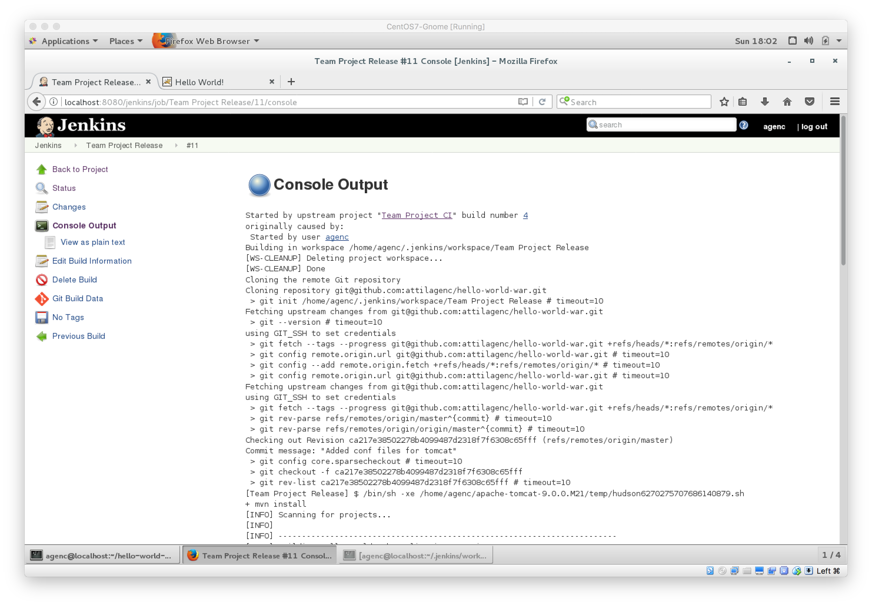

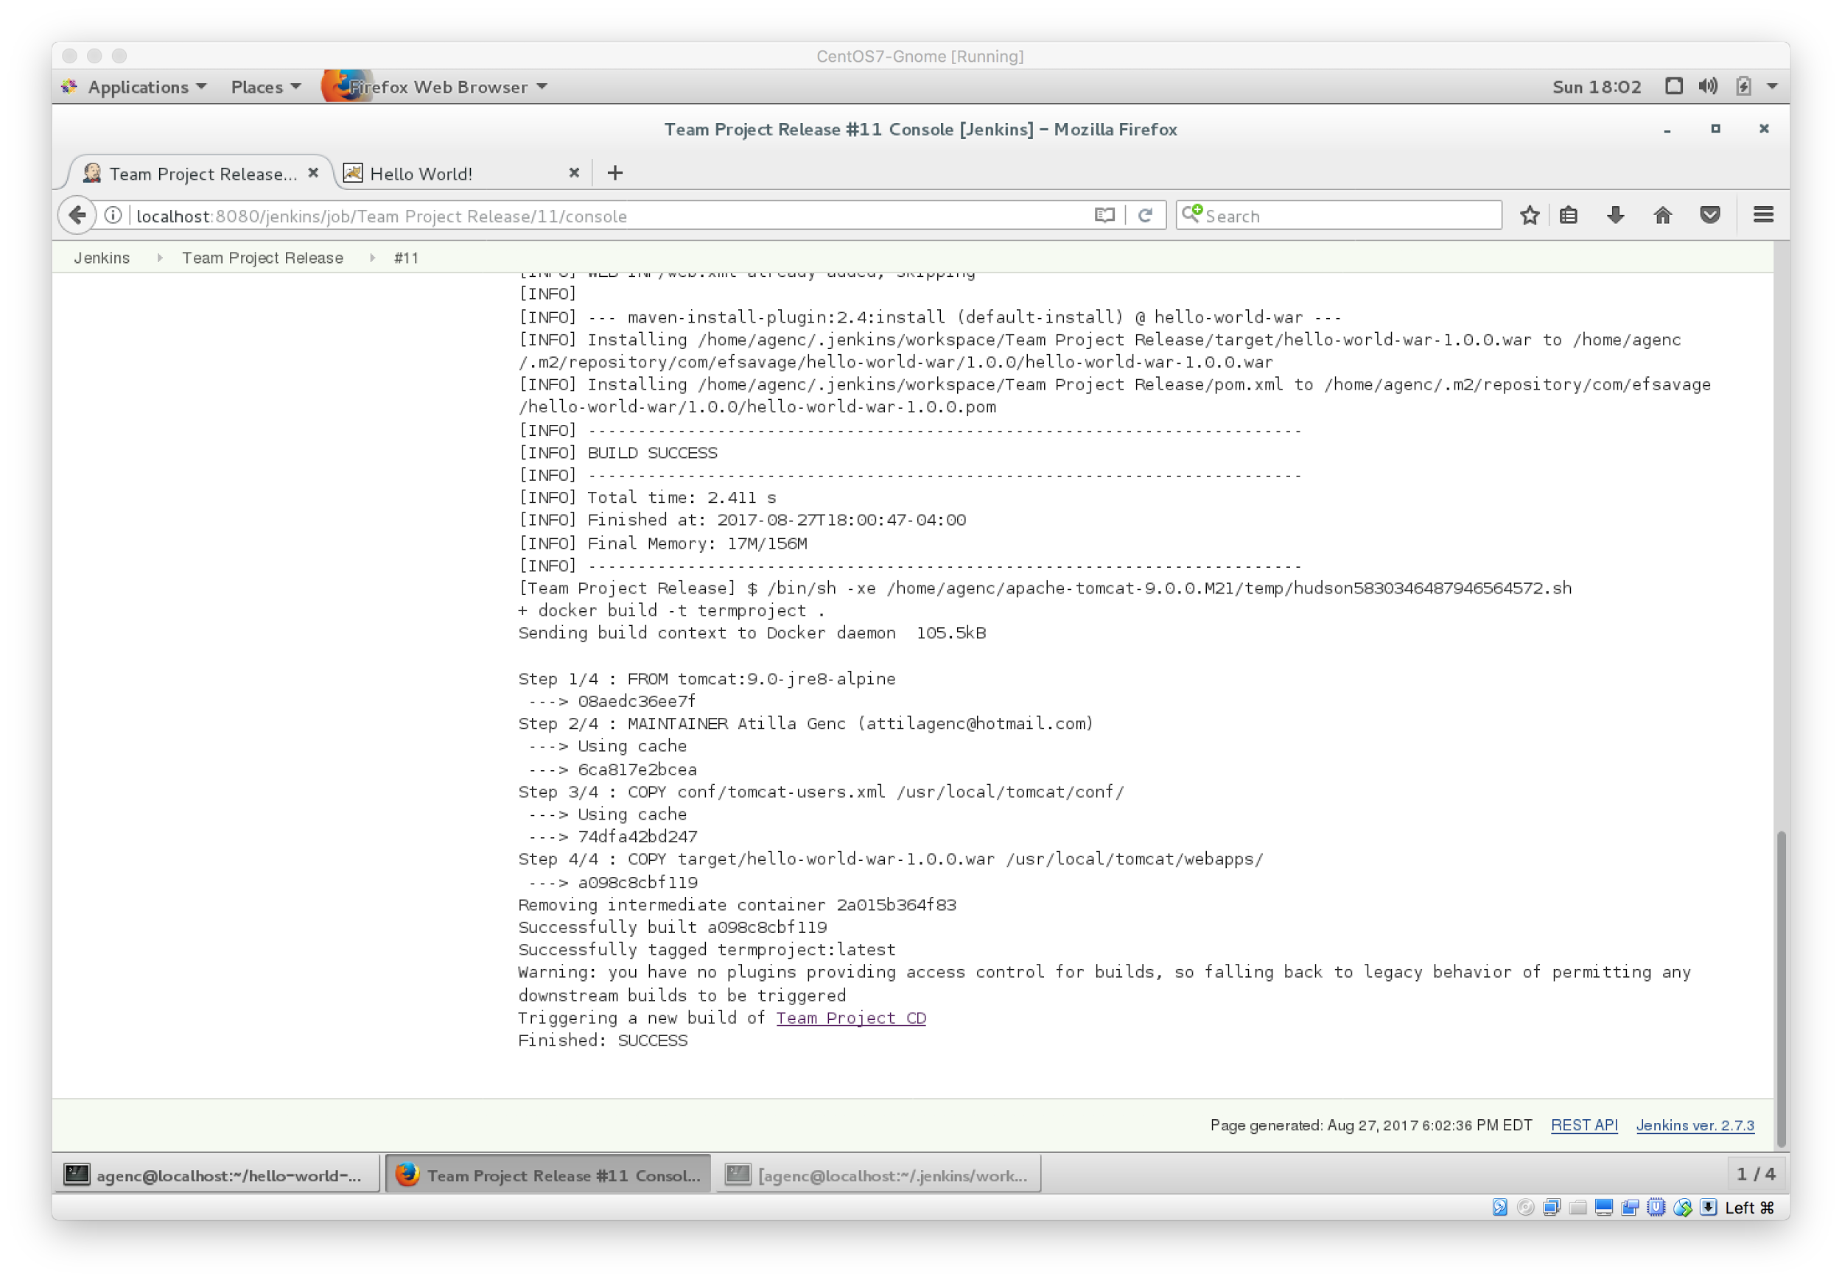

Sample Output from Continuous Deployment Job

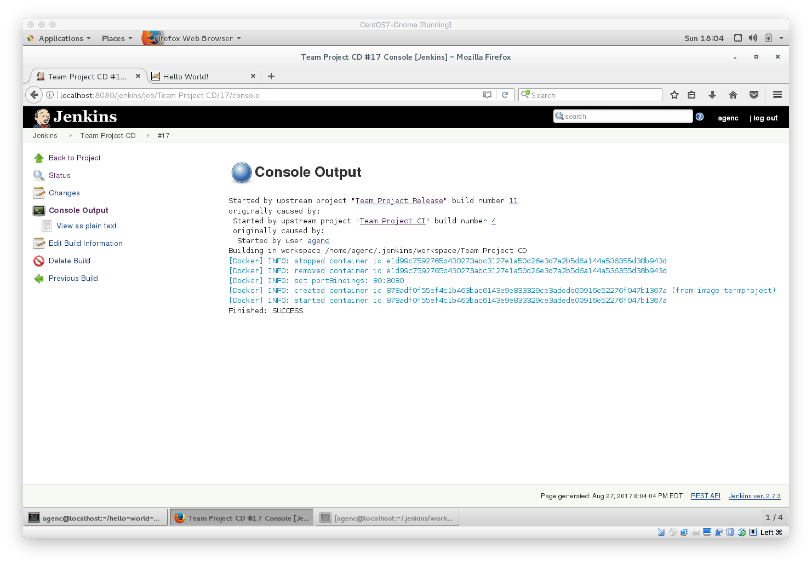

Output from deployed application

